I



## Major Project

### 20MCA41

**On**

**“Covid Patient Tracing and Diagnosis System”**

**Submitted by**

**ISHITA SARKAR**

**USN: 1RV20MC028**

**Under the Guidance**

**Of**

**Internal Guide External Guide**

**Dr. Jasmine KS**

**Associate Professor**

**Department of MCA**

**RV College of Engineering**® **Bengaluru – 560059**

**Parag Jain Reporting Analyst**

**EXL Services**

**Bengaluru – 560103**

***Submitted in partial fulfillment of the requirements for the award of degree of***

### MASTER OF COMPUTER APPLICATION

**2021-2022**

**RV COLLEGE OF ENGINEERING ®**

**(Autonomous Institution Affiliated to Visvesvaraya Technological University, Belagavi)**

### DEPARTMENT OF

**MASTER OF COMPUTER APPLICATIONS**

[**Bengaluru**](http://www.bengaluruairport.com/)**– 560059**

 ®

**CERTIFICATE**

Certified that the project work titled “**Contact Tracing using GPS Data and Machine Learning”** carried out by **ISHITA SARKAR, USN:1RV20MC028, a** bonafide student of **RV College** of **Engineering**®**, Bengaluru** submitted in partial fulfillment for the award of Master of Computer Applications of **RV College of Engineering®, Bengaluru affiliated to Visvesvaraya Technological University, Belagavi** during the year **2021-22.** It is certified that all corrections/suggestions indicated for criteria assessment have been incorporated in the report deposited in the departmental library. The project report has been approved as it *satisfies* the academic requirement in respect of project work prescribed for the said degree.

**Dr. Jasmine KS**

Associate Professor Department of MCA

RV College of Engineering®

Benga1uru —59

**Dr. Andhe Dharani**

Professor and Director

Department of MCA

RV College of Engineering®

Benga1uru —59

**Dr. KN Subramanya** Principal

RV College of Engineering®

Benga1uru—59

`  **RV COLLEGE OF ENGINEERING ®**

**(Autonomous Institution Affiliated to Visvesvaraya Technological University, Belagavi)**

### DEPARTMENT OF

**MASTER OF COMPUTER APPLICATIONS**

[**Bengaluru**](http://www.bengaluruairport.com/)**– 560059**

DECLARATION

I, **ISHITA SARKAR**, student of fourth semester MCA in the **Department of Master of Computer Applications,** RV College of Engineering®, Bengaluru declare that the project titled **“Contact Tracing using GPS Data and Machine Learning”** has been carried out by me. It has been submitted in partial fulfillment of the course requirements for the award of degree in **Master of Computer Applications of RV College of Engineering®, Bengaluru affiliated to Visvesvaraya Technological University, Belagavi** during the academic year **2021-22**. The matter embodied in this report has not been submitted to any other university or institution for the award of any other degree or diploma.

**Date of Submission: Signature of the Student Student Name: Ishita Sarkar**

USN:1RV20MC028

Department of Master of Computer Applications RV College of Engineering®

Bengaluru-560059

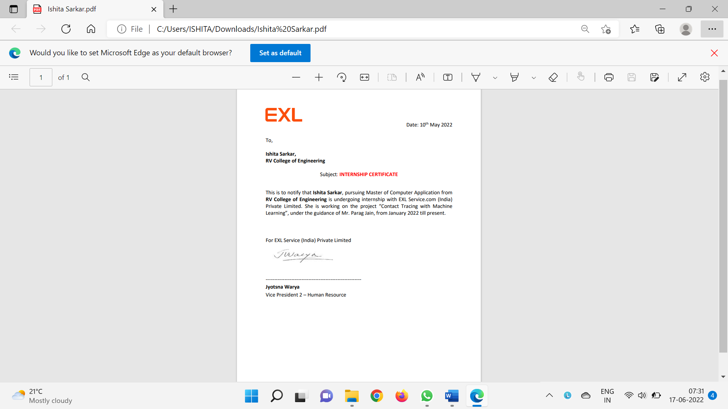

**ACKNOWLEDGEMENT**

The satisfaction and euphoria that accompany the success of any work would be incomplete unless I mention the name of the people, who made it possible, whose constant guidance and encouragement served a beacon light and served our effort with success.

I express my wholehearted gratitude to the **Dr. Subramanya K N**, Principal, RV College of Engineering® for providing me an opportunity.

I express my special thanks to **Dr. Andhe Dharani**, Professor and Director, Department of MCA, RV College of Engineering®, Bengaluru for her constant support and guidance.

I express my sincere thanks and wholehearted credit to my Internal guide **Dr. Jasmine K S**, Associate Professor, Department of MCA, RV College of Engineering®, Bengaluru for her constant encouragement, support and guidance during the project work.

I am very thankful to my External guide **Parag Jain** for all her support and guidance. I am also very thankful to all the lab in-charge staff and all faculty of the department for their help and support during the project.

On a more personal note, my deepest appreciation and gratitude to my beloved family, who have been a fountain of inspiration and have provided unrelenting encouragement and support.

**ISHITA SARKAR**

**1RV20MC028**

Department of MCA

RV College of Engineering®

Bengaluru-59

**ABSTRACT**

**T**racking, screening, and forecasting existing and future infected cases, early detection and diagnosis of infection, medicine and vaccine research, and lowering the burden of healthcare professionals are all essential uses of artificial intelligence (AI) in the battle against the COVID-19 pandemic. COVID-19's propagation may potentially be handled as a data science problem. Non-traditional strategies for processing COVID-19 data, such as data collection and interpretation, modelling, prediction, and data visualization and communication, are required to manipulate COVID-19 infection dynamics.

If a person is diagnosed with Covid-19 and the diagnosis is confirmed, the next critical step is contact tracing to prevent the disease from spreading further. So how exactly can one achieve it, first of all, all the GPS data of the infected person is being collected. Next one need to choose an appropriate algorithm to render data such as Density-based Clustering, Hierarchal-based Clustering, Partitioning-based Clustering using the KNN technique etc. Further the data is passed through the chosen Machine Learning algorithm where its being processed and depict the rendered data in graphical format. Finally, test the trained algorithm with test data to check it’s performance. The software technologies used for the above-mentioned steps are Python and Python libraries such as NumPy, Pandas and matplotlib; Machine Learning algorithms, and Jupyter notebook to compile our code/algorithm, and the hardware requirements are, Desktop or a laptop with minimum of 4-8 Gb RAM. The above steps are designed to collect individual personal data, which will be analyzed by ML and AI tools to track down someone vulnerable to the new virus due to their recent chain of contacts.

If used thoroughly, this idea can break the chain of transmission of the current novel coronavirus and suppress the epidemic by providing greater opportunities for adequate controls and helping to reduce the extent of the recent pandemic. The digital contact tracing process can be done virtually in real-time and much faster than the non-digital system which reduces manual effort and increases accuracy. The expected accuracy of the proposed system is about 80-90%.

## Table of Contents

|  |  |  |
| --- | --- | --- |
| **CONTENTS** |  | **PAGE NO.** |
| College Certificate |  | ii |
| Declaration by student |  | iii |
| Company Certificate |  | iv |
| Acknowledgment |  | v |
| Abstract |  | vi |
| Table of Contents |  | vii |
| List of Tables |  | ix |
| List of Figures  **Chapter 1: Introduction** |  | x  **1** |

* 1. Introduction 1
  2. Project Description 1
  3. Company Profile 3
  4. Dissertation Organization 4

Chapter 2: Literature Review 6

* 1. Literature Survey 6
  2. Existing and Proposed System 12
  3. Tools and Technologies used 13
  4. Hardware and Software Requirements 17

Chapter 3: Software Requirement Specifications 18

* 1. Introduction 18
  2. General Description 18
  3. Functional Requirements 20
  4. Non-Functional Requirements 22
  5. Design Constraints 22

Chapter 4: System Design 23

* 1. System Perspective /Architectural Design 23
  2. Context Diagram 26

Chapter 5: Detailed Design 27

5.1 System Design 27

**Chapter 6: Implementation**  33

* 1. Code Snippets / PDL 33
  2. Implementation 37

Chapter 7: Software Testing 44

* 1. Test cases 44

Chapter 8: Conclusion 52

Chapter 9: Future Enhancements 53

Bibliography 5

|  |  |  |
| --- | --- | --- |
| Table No | Title | Page No. |
| 7.1 | **Unit test cases for Extraction of data** | 45 |
| 7.2 | **Unit test cases for Locating covid patients** | 46 |
| 7.3 | **Unit test cases for Locate people who came in contact with the infected patient** | 48 |
| 7.4 | **Unit test cases for check if other people located were covid infected or not** | 49 |
| 7.5 | Unit test cases to check if the probability value predicted is correct | 50 |

|  |  |  |
| --- | --- | --- |
| Figure No | Title | Page No |
| 4.1 | **Architecture Diagram** | 23 |
| 4.2 | **Block Diagram** | 24 |
| 4.3 | **Context Diagram** | 26 |
| 5.1 | **Use Case Diagram** | 27 |
| 5.2 | **Activity Diagram** | 28 |
| 5.3 | **DFD Level – 0** | 29 |
| 5.4 | **DFD Level – 1** | 29 |
| 5.5 | **DFD Level-2 Patient Tracking** | 30 |
| 5.6 | **DFD Level-2 Infected Patient Diagnosis** | 30 |
| 5.7 | **Final DFD** | 31 |
| 5.8 | **Sequence Diagram** | 32 |
| 6.1 | **Clusters** | 37 |
| 6.2 | **Clusters with noise** | 38 |
| 6.3 | **Clusters without noise** | 39 |
| 6.4 | **Choose Random id** | 40 |
| 6.5 | **Plotting single Patient** | 40 |
| 6.6 | **List of people who came in contact** | 41 |
| 6.7 | **Plotting newly identified individuals** | 41 |
| 6.8 | **Plotting infected and non-infected people** | 42 |
| 6.9 | Probability of a person getting infected | 43 |

### CHAPTER 1

### INTRODUCTION

1. **Introduction**

The Coronavirus-2 and its associated illness, coronavirus disease COVID which was first detected in China in late 2019, pose the most significant public health threat in the past 100 years. This sickness has swept the globe like wildfire. The worldwide reaction to the outbreak has been patchy. Some governments reacted quickly and efficiently, while others failed terribly. Strict lockdowns are one means of restricting viral propagation; however, this comes with a high economic cost due to company closures and job losses, and there is a chance that the spread will restart once the lockdowns are lifted.



##### Project Description

To combat COVID, most governments have focused on developing smart lockdown tactics that use a number of technological solutions. Overall, early disease prevention initiatives and a mix of high and low-tech solutions enabled several nations (such as China and South Korea) to limit disease spread. These countries rely on passengers being monitored and quarantined. Human movement was severely hampered in the early days of the outbreak. People began to withdraw within their houses. However, it resulted in the closure of the transportation industry. Individuals with minimal risk were also asked to adhere to quarantine, and their physical presence was either monitored by state operatives or tracked via cell tower location data. Identified patients were kept in covid wards for about a fortnight, determined by the availability of health care facilities.

Tracking, screening, and forecasting existing and future infected cases, early detection and diagnosis of infection, medicine and vaccine research, and lowering the burden of healthcare professionals are all essential uses of AI in the battle against the

covid pandemic. The propagation may potentially be handled as a data science problem. Non-traditional strategies for processing covid data, such as data collection and interpretation, modelling, prediction, and data visualization and communication, are required to manipulate covid infection dynamics.

If a person is diagnosed with Corona virus and the diagnosis is validated, the next crucial step is to trace the person's contacts in order to prevent the According to the World Health Organization, the virus is spread mostly by saliva, droplets, or nasal secretions. Contact tracing is an vital public health method for preventing the transmission of SARS-Cov-2. Contact tracing is a way of recognizing and monitoring people who have recently been in contact with a Covid patient in order to keep the spread of the virus further. In general, the method detects the ill person 14 days after the exposure.

If implemented completely, this approach has the potential to break the chain of transference of the present new coronavirus and suppress the epidemic by increasing options for effective controls and assisting in the reduction of the contemporary pandemic's scope. In this regard, a method of digital contact tracing with a mobile application is available in many affected countries, leveraging a variety of technologies such as GPS, Bluetooth, and smartphone tracking data. The digital contact tracing method is substantially faster than the non-digital technique and may be completed virtually in real time. All these digital apps are intended to capture an individual’s personal details, which will be processed by Machine Learning algorithms and techniques to identify people who are at risk to the new virus owing to their recent string of interactions.

##### Company Profile

Insurance, healthcare, banking and financial services, media, retail, and other industries are served by EXL Service, a worldwide analytics and digital solutions firm. The company's headquarters are situated in New York, and it employs over **30,000+** people across various countries and continents.

Vikram Talwar and Rohit Kapoor co-founded EXL in the year 1999. Vikram Talwar served the company as CEO as well as a vice-chairman after the company was founded in year 1999. Rohit Kapoor is the company's CEO as well as the vice-chairman of the company at the moment. Kapoor has previously held the post of president of the corporation. Conseco bought EXL in August 2001 and ran it as a completely owned subsidiary. Conseco sold the firm to Oak Hill Capital Partners and FTVentures in 2002. On October 20, 2006, the company's shares began trading on the NASDAQ market under the ticker EXLS.

With the purchase of peer business Inductis, EXL embarked along the route of expansion through acquisitions shortly before its NASDAQ debut. This acquisition was made to diversify EXL's income stream; previous to the acquisition, business process outsourcing (BPO) accounted for 90% of EXL's revenue; after the acquisition, BPO accounted for 70% of EXL's revenue, with the rest coming from research and analytics and advisory services. Through the acquisition of OPI in 2011, EXL increased their distribution reach in Eastern Europe and Southeast Asia. EXL was said to have planned a massive purchase spree in the US healthcare business in 2013, in response to the Affordable Care Act's inception and demand that all Americans have health insurance.

The healthcare market accounted for around 10% of EXL's revenue at the time of this study in 2013.

EXL set foot in Latin America in 2014 by the way of a strategic joint venture with CT&S, which paired EXL's technical prowess with CT&S's local understanding and brand image. EXL's escalating client base for Spanish-language services was also amplified by this joint venture. EXL expanded its healthcare analytics capabilities by acquiring SCIOInspire Holdings in 2018.EXL purchased Clairvoyant in 2021, gaining scale in data, artificial intelligence, and cloud engineering.

##### Dissertation Organization

The remaining dissertation is arranged as follows:

**Chapter 1: Introduction**

In first chapter the part includes the description of the project i.e., what is the need of this project, what are the tools required to develop this project and what will be the outcome of this project. Second part includes brief introduction about the company and domain in which this project is based on. Third part includes the technical features of this project.

**Chapter 2: Literature Survey**

It consists of four segments where the first part discusses about any literature survey done with respect to content related to the project. The second part is about the existing & proposed systems. The tools & technologies used for project will be third and the requirements of hardware & software for running the project is the fourth segment

**Chapter 3: Software Requirement Specification**

In third chapter the first part includes the brief introduction of the project, abbreviations used while writing the document and overview of the project. The second part includes functional requirements i.e., the modules used in the project and what will be the input, processing and output of each module. It also includes non-functional requirements, design constraints i.e., hardware limitations and software compliance.

**Chapter 4: System Design**

Chapter 4 is all about system design i.e., a bigger view of the project on a large scale by explaining the problem and specifying the modules

Chapter 5: Detailed Design Fifth chapter includes the description of the detailed design. It includes object modelling which contain class diagram for the project, dynamic modelling which contains use case diagram, sequence diagram and activity diagram, functional modelling which contain data flow diagrams. These diagrams are included to describe the flow of the project.

**Chapter 6: Implementation**

This chapter provides code snippets related to the project & an explanation to implementation of the modules along with screenshots is given.

**Chapter 7: Testing**

Seventh chapter includes testing. It includes test cases for each module. This chapter include one failed test case.

**Chapter 8: Conclusion**

This chapter tells the whole summary of the project, comparison of existing system and proposed system and what all new things have been implemented.

**Chapter 9: Future Enhancements**

This chapter gives any future works/improvements that can be implemented in the future to improve and enhance the overall efficiency of the project.

### 

### CHAPTER 2

### LITERATURE REVIEW

##### Literature Survey

Individuals' Rustam, F., Reshi, A., and Mehmood, "COVID-19 Future Forecasting Using Supervised Machine Learning Models”, Machine learning (ML)-based forecasting techniques have demonstrated their use in predicting perioperative outcomes and improving decision-making about future actions. Many application fields that required the detection and prioritization of adverse aspects for a threat have long used machine learning models. The research shows that machine learning algorithms can predict the number of patients who would be afflicted by COVID-19, which is now regarded as a possible threat to humanity. Each of the models makes three types of predictions: the number of newly infected cases, the number of fatalities, and the number of recoveries the next ten days The study's findings show that using these strategies in the current COVID-19 pandemic scenario is a promising mechanism [1].

"Regression Analysis of COVID-19 Using Machine Learning Algorithms," with the guide of utilizing Ekta Gambhir, Ritika Jain, Alankrit Gupta, and Uma Tomer (2020). The original Coronavirus keeps on being an approaching danger to general wellbeing, and dropping down in records as one of the worldwide's most terrible pandemics is going. The expectation is to offer donors an additional a skill of the manner in which unique Machine Learning designs is most likely used in genuine worldwide situations. This concentrates moreover looks at the overarching design or test of Covid-19 transmission in India, further to the overall numbers. This analyze utilizes records from the Indian Ministry of H(health)F(Family)Welfare to give severa advancements and styles situated in different components of the worldwide. The records for this inspect become accumulated over a span of 154 days. The kind of dataset is the reason relapse assessment become chosen for the current day inconvenience proclamation. Since the dataset is relentless, relapse assessment is top of the line ideal for foreseeing a constant laid out factor from a fixed of fair-minded factors [2]. M. A. Sarwar, N. Kamal, W. Hamid, and M. A. Shah (2018, September). "In Healthcare, Prediction of Diabetes Using Machine Learning Algorithms." In a variety of industries, machine learning techniques are utilised to do predictive analytics over massive data. Predictive analytics in healthcare is a difficult task, but it can ultimately assist practitioners in making timely decisions regarding a patient's health and treatment based on huge data. This study examines predictive analytics in healthcare, and it employs six different machine learning algorithms. A dataset of a patient's medical record is gathered for the experiment, and six different machine learning algorithms are applied to the dataset. The performance and accuracy of the algorithms used are compared and reviewed. The various machine learning approaches employed in this study are compared. A new study indicates which algorithm is superior for diabetes prediction. The goal is to use machine learning techniques to assist doctors and practitioners in the early detection of diabetes [3].

D. Dahiwade, G. Patle, and E. Meshram (2019, March). "Utilizing a Machine Learning Approach to Design a Disease Prediction Model." People are inclined to a whole parcel of infirmities due to their living way of behaving and the US of the climate. Thus, foreseeing contamination at an early recognition will turn into a fundamental errand. Nonetheless, logical clinical specialists figure out it hard to make specific expectations dependent generally upon side effects and side effects. The most troublesome undertaking is productively foreseeing contamination. To treatment this issue, measurements mining plays a fundamental component in disease forecast. Clinical innovative information produces a magnificent measure of insights every year. The appropriate appraisal of clinical insights has been profited from early impacted character care because of the sped up measure of insights development withinside the clinical and medical services fields. Information mining uncovers stowed away examples the use of sickness measurements. measurements covered in a heap of clinical measurements. Where the predominant sickness forecast dependent totally upon the impacted person's side effects and side effects. For compelling ailment expectation, hence the K-Nearest Neighbor (KNN) and Convolutional Neural Network (CNN) framework concentrating on calculations. An assortment of disease side effects and side effects is needed for sickness expectation. For an exact visualization, the person's dwelling conduct and exam measurements are viewed as in this exquisite ailment expectation. The CNN set of guidelines has an exactness of 84.5 percent in exquisite sickness forecast, this is higher than the KNN approach. Furthermore, KNN makes some higher memories and memory need than CNN. Subsequent to anticipating exquisite disease, this instrument can compute the gamble of rich sickness, showing whether or presently as of now not the gamble is lower or higher [4].

S. Subudhi, A. Verma, A. B. Patel, C. C. Hardin, M. J. Khandekar, H. Lee, et al (2021). In COVID-19, researchers compared machine learning methods for predicting ICU admission and death. Machine learning methods could help clinicians identify high-risk individuals because forecasting COVID-19's course is difficult. The results of 18 machine learning algorithms for predicting ICU admission and mortality in COVID-19 patients are compared in this study. The generated and internally validated models using COVID-19 patient data from the Mass General Brigham (MGB) Healthcare database, and then further evaluated them using temporally diverse individuals who presented to the ED between May and August 2020 (n = 1711). Ensemble-based models outperform traditional models, according to our findings. COVID-19 predicts 5-day ICU admission and 28-day death better than other model types. CRP, LDH, and O2 saturation were important for ICU admission models, but the most relevant factors for predicting mortality were eGFR 60 ml/min/1.73 m2 and neutrophil and lymphocyte percentages. Such models could aid clinical decision-making in the event of future infectious disease epidemics, such as COVID-19 [5].

"A Survey of Mathematical, Machine Learning, and Deep Learning Models for COVID-19 Transmission and Diagnosis," by C. C. John, V. Ponnusamy, S. K. Chandrasekaran, and R. Nandakumar, 2021. COVID-19 is a life-threatening virus with worldwide ramifications. Drugs and vaccines have yet to be found because the disease is caused by a new coronavirus with unknown gene information. For the time being, illness spread analysis and prediction using a mathematical and data-driven model will be extremely useful in initiating prevention and control measures such as lockdown and quarantine. Various mathematical and machine-learning methods have been suggested for assessing and predicting the spread. For a given circumstance, each model has its own set of constraints and benefits. To provide greater insight, this paper covers state-of-the-art mathematical models for COVID-19, including compartment models, statistical models, and machine learning models, in order to find an acceptable model for disease spread analysis. Furthermore, a precise COVID-19 diagnosis is another critical step in identifying the infected person and preventing further dissemination. Because the virus is spreading quickly, there is a need for an automated diagnosis system that can manage a huge population. Diagnostic mechanisms based on deep learning and machine learning will be more appropriate for this purpose [6].

R. Sujath, J. M. Chatterjee, and A. E. Hassanien (2020). "A COVID-19 pandemic estimating form the use of device acquiring information on in India." With realities examination and realities mining, records and report time helps withinside the dynamic system principally founded absolutely on notable realities. The amount of realities to be had is colossal, making gathering records and removing an intriguing example from it a hard endeavor. The cutting edge realities on affirmed, recuperated, and downfall in India throughout a drawn out time span supports foreseeing and estimating the near predetermination. The rendition's exactness will be progressed through incorporate additional abilities including numerous clinics, the impacted individual's resistant framework, the patient's age, orientation, and the endeavors taken to struggle the unfurl of the ailment of the infection, etc, so one can offer total records. Starting today, it is imperative that yards to hold be severe and cautious in nature so one can address this fundamental condition through friendly partition, lockdown, time limit, quarantine, and seclusion. One can likewise furthermore complete that the MLP strategy produces higher expectation results than the LR and VAR procedures using WEKA and Orange through looking through on the expected qualities and assessing them to models from John Hopkins UniversityFootnote11 realities. Thus one can utilize profound acquiring information on cycles to gauge time assortment realities withinside the predetermination to create higher forecasts [7].

Gupta, Rajan, Manan Bedi, Prashi Goyal, Srishti Wadhera, and Vaishnavi Verma are the people of the (2020). "Examination of COVID-19 Tracking Tool in India: Case Study of Aarogya Setu Mobile Application" Different states of their different countries are quickly developing COVID-19 checking stuff or contact-following applications. The Aarogya Setu instrument, progressed with the guide of utilizing the Indian specialists, is the worry of this analyze. It is a telephone programming progressed with the guide of involving the Ministry of Health as a piece of the E-Governance endeavor to tune and show Indian residents withinside the battle towards the unfurl of COVID-19. The look's at will probably learn about the apparatus' severa abilities and to give assorted measurements innovation ideas utilized withinside the product, notwithstanding the device's value in taking care of the proceeding with pandemic. At the point when an individual is near a COVID-19 excited individual, the application utilizes Bluetooth and GPS period to tell them. To investigate COVID-19 unfurl in India, the product utilizes various Data Science ideas comprising of order, alliance rule mining, and bunching. The look at moreover shows possible moves up to the program, comprising of utilizing AI and PC creative and judicious to go over COVID-19 patients. Versatile period subject matter experts, measurements innovation experts, logical specialists, wellbeing related forefront representatives, public overseers, and specialists officials could all partake in the examination [8].

J. Berglund, J. Berglund, J. Berglund, J. Berglund "There's an App for That: COVID-19 Tracking" Vice President Mike Pence advised the snap in March 2020, sooner than COVID-19 laid proclaim to the United States, at the Covid pestilence, which on the time turned into a threat to travelers on board the Grand Princess journey convey secured off the bank of California [1]. Cases had ascended in Iran, Italy, and Spain on the time, but the disorder turned out to be regardless a spine chiller to most extreme Americans. At the point when mentioned roughly a possible episode in Washington, D.C., Vice President Mike Pence alluded the subject to Dr. Anthony Fauci, top of the National Institute for Allergy and Infectious Disease and an individual from America a Task Force. Fauci expressed that each and every individual who inspected great for the affliction could be exposed to contact following, which he characterized as "the overall population wellness weapon" for halting episodes. The World Health Organization proclaimed a global pandemic now at this point not extended later, and the infection began to unfurl all through the country [9].

C. Sandeepa, C. Moremada, N. Dissanayaka, T. Gamage, and M. Liyanage. Sandeepa, C., Moremada, C., Dissanayaka, N., Gamage, T., and Liyanage, M. (2020, September). "A System for Tracking Social Interactions and Predicting Potential COVID-19 Patients" Allowing for proper social distancing and isolation or confinement to identify possible patients is the greatest strategy to prevent the virus from spreading quickly. Because the virus has a 14-day incubation period, it's critical to track all social interactions during that time and place such potential patients in social isolation. For the time being, however, proper social interaction tracking systems and patient prediction algorithms based on this data are lacking. This study looks at how to track users' social interactions and forecast infection risk based on such interactions. So in beginning a social contact tracking system based on BLE (Bluetooth Low Energy) and GPS was developed. Then, using the obtained data, an algorithm was created to estimate the likelihood of becoming infected with COVID-19. Finally, a system prototype with a mobile app and a web monitoring tool is implemented. In addition, then a graph-based model was to simulate the system and assess the behaviour of the proposed algorithm, which confirms that self-isolation is significant in slowing illness progression [10].

R. Mallik, D. Sing, and R. Bandyopadhyay (2020). "GPS Tracking App for Police to Track COVID-19 Patients for Safe Distancing." Traffic congestion is unavoidable in places with high population density, such as Bengaluru and Mumbai. According to the TomTom traffic index for 2019, Bengaluru is the world's most congested city, with Mumbai in fourth place. Transporting a COVID-19 patient between two locations quickly during a traffic jam could be difficult. The position information of an ambulance transporting COVID-19 patients may be valuable to traffic cops in isolating the ambulance from crowded areas and directing them to clear roads, allowing the patients to be relocated more quickly [11].

S. Saha, S. Maity, T. Bhattacharyya, T. Bhattacharyy (2021, February). "An Application Based on GPS Tracking and QR Code Scanner to Assist Health Workers and Ordinary Citizens During Covid-19" The pollution expense unleashed obliteration over the world, first influencing European global areas lastly the United States. Thus, on this work, so the suggestion was to develop a product program utility that gathers individual records to process the risk principally based absolutely at the merits of a re-did overview, provoking the individual to confirm assuming they might be encountering any medicinally settled side effects, after which sends it to the area civil center. Thus, the requirement for logical workers to move house to house on a customary premise, gambling with tainting, can be diminished. This product program comprises of GPS following, a danger stage forecast, a contamination diagram, and the ability to compute logical earnestness, among various things. Basically, our gadget is intended to direct consistently representatives and go to places in high-peril circumstances. This proposed period is utilized to confine capacity suggestive and asymptomatic clients from getting into public spots comprehensive of division shops and markets in area of interest zones. The product program will create a totally extraordinary QR code for each individual, for you to show their all around certainly worth basically founded absolutely on a mandatory study to conclude whether or presently no longer they might be impacted [12].



##### Existing and Proposed System

##### Problem statement

##### The health sector is always in need of new technology, whether it's in the shape of gear or software that can do important jobs. When Covid struck, there was no means to fight the disease or even tell if someone was sick or not, which was a critical period for the health domain. During the Covid-19 epidemic, the number of persons infected worldwide increased dramatically, with the majority of those infected coming into touch with people who were already infected or showing symptoms.

##### Scope of Project

##### Machine learning is a cutting-edge method with numerous applications in prediction. For the COVID pandemic, this technique must be used to detect high-risk patients, persons who have come into touch with positives, and other abnormalities. Rather than a standard overtly calculation-based method, it gives accurate and valuable features. Furthermore, this technique is useful in predicting the danger of COVID in healthcare during this crisis. Machine learning considers risk factors such as age, location, and climate.

##### Tools and Technologies

###### Python

###### Python's design philosophy stresses code readability, as seen by the extensive usage of whitespace.All programming paradigms are supported, including structured programming (particularly procedural), object-oriented programming, and functional programming.

###### Jupyter

###### Jupyter is actually and interaactive computing environment that enables users to edit and run code from the browser,create and use interactive javascript widgets,author narrative text using markup languauge . It is a web-based interface that allows for rapid prototyping and sharing of data-related projects. It works with many kernels (this is the name given to the code env that it can run), including but not limited to Pyhton and R (even though its more famous and suited for Python). In the old days, it used to be called IPython Notebook but has been renamed and moved to the Jupyter project. Jupyter is an open-source project aiming at creating a better work experience for (data) scientists. You can learn more and get a better definition by browsing their website. Basically ,it allows you to program in a web browser-its a mix of code, instructions and output and all of this information is displayed inline in one web page which makes it very useful for writing a code that tells a story,also it provides a self contained record of computation that can be converted into various formats and shared using email ,dropbox ,version control system like github. First you have to understand the purpose of notebooks or notebook documents. These are documents in which you bring together code and rich text elements (figures, links, equations, …). In the case of Jupyter Notebook, these notebook documents can be produced by the Jupyter Notebook App. The use cases in which you need to join your code and rich text elements in one document are quite varied: you might be working on a data science project, or building your data science portfolio, or you’re making a dashboard or an ETL flow, … You might also use Jupyter Notebook for research purposes. On a bigger scales, data science teams can use Jupyter Notebooks to collaborate on projects. These use cases explain why you saw a link to the Jupyter project on a Pandas page. As a data manipulation and analysis package for Python, Pandas can really be used in most

###### (if not all) use cases that are described above. Nevertheless, you can also see why

###### Pandas isn’t the only package that can come in handy in a data science project or a dashboard. According to your use case, you might resort to, for example, the other typical Python data science libraries that are out there. I would consider all that I have said before the basic use of the Jupyter Notebooks. You can do much more, as Jupyter Notebook also allow you to run many other languages, such as R, Julia, Scala, SAS, you can easily make a notebook document that contains code that is another programming language than Python and you can interactively switch between languages in your notebook documents.

###### CSV

###### A CSV is a comma-separated values record, which lets in records to be stored in a tabular format. CSVs seem like a garden-range spreadsheet however with a .csv extension.CSV documents may be used with maximum any spreadsheet program, together with Microsoft Excel or Google Spreadsheets. They fluctuate from different spreadsheet record kinds due to the fact you may best have a unmarried sheet in a record, they cannot keep cell, column, or row. Also, you can't now no longer keep formulation on this format.

###### Pygal

###### Pygal is an open-supply information visualization library in Python. It is one of the exceptional python libraries to create distinctly interactive plots and charts for unique datasets. Also, it lets in you to down load your visualizations in SVG (Scalable Vector Graphics) or PNG (Portable Graphics Format) for more than one programs and personalize it accordingly.

###### DBSCAN

###### Grouping evaluation or unquestionably Clustering is essentially an Unsupervised perusing technique that partitions the measurements components into various one-of-a-kind clumps or associations, to such an extent that the measurements components withinside similar associations have comparative homes and measurements components in unmistakable associations have particular homes in some sense. It comprises of numerous unmistakable techniques put together absolutely for the most part with respect to differential advancement. For example K-Means (distance among

###### components), Affinity proliferation (chart distance), Mean-shift (distance among

###### components), DBSCAN (distance among closest components), Gaussian blends (Mahalanobis distance to focuses), Spectral grouping (diagram distance) and so on. Essentially, all bunching procedures utilize a similar strategy for example first we compute similitudes and afterward we use it to group the insights components into associations or clusters. Here they equipped for cognizance on Density-based absolutely totally spatial grouping of utilizations with commotion (DBSCAN) bunching technique. Bunches are thick locales withinside the measurements space, isolated by means of districts of the lower thickness of components. The DBSCAN set of strategies is put together absolutely totally with respect to this natural idea of "bunches" and "commotion". The key thought is that for every component of a group, the organization of a given range needs to envelop basically a base measure of components.

###### Pandas

Pandas may be a software program library written for the Python programming language for statistics manipulation and evaluation. Particularly, it gives statistics systems and operations for manipulating numerical tables and statistic. It's unfastened software program launched below the three-clause BSD license. the decision is derived from the time period "panel statistics", a stochastics period of time for statistics units that consist of observations over more than one-time durations for the equal individuals. Its call may be a play at the phrase "Python statistics evaluation" itself. Wes McKinney began out constructing what might grow to be pandas at AQR Capital whilst he changed into a researcher there from 2007 to 2010. Pandas is especially used for statistics evaluation and related manipulation of tabular statistics in Dataframes. Pandas lets in uploading statistics from numerous report codecs which include CSV, JavaScript Object Notation, Parquet, SQL, and MS Excel. Pandas lets in numerous statistics manipulation operations which include merging, reshaping, selecting, in addition to statistics cleaning, and statistics wrangling functions. The improvement of pandas brought into Python many similar functions of operating with Dataframes that have been installed withinside the R programming language. The

pandas library is made upon some other library named NumPy, that's orientated to effectively operating with arrays in preference to the functions of operating on Dataframes.

**Numpy**

NumPy can be a library for the Python programming language, as well as working with huge, multi-faceted clusters and grids, joined with an enormous arrangement of undeniable level numerical capacities to perform on such exhibits. . NumPy's connection, Numeric, was initially made with the assistance of Jim Hugunin's work with commitments from totally various engineers. In 2005, Travis Oliphant made NumPy utilizing the coordination of Numarray contender capacities into Numeric, with significant changes. NumPy is an open source programming framework program and has various benefactors. NumPy is an undertaking upheld by NumFOCUS in charge matters. NumPy is focused on Python's CPython reference execution, for example an enhanced bytecode translator. Math calculations composed for this Python model frequently run a horrendously related stack more slow than incorporated identical calculations because of absence of compiler enhancement. NumPy takes care of the issue of gradualness with the assistance of four-layered cluster mining, abilities and administrators that function admirably on exhibits; utilizing them joins code altering, predominantly inward circles, utilizing NumPy. Mining NumPy in Python gives MATLAB happiness for however long they are deciphered, permitting anybody to compose quick applications as long as most tasks are performed on exhibits or grids and not on aimless. By examination, MATLAB has a ton of extra toolboxs, including Simulink, while NumPy itself is coordinated with Python, a stylish and extensive extra programming language. Moreover, extra Python programs are accessible; SciPy can be a library with extra MATLAB-like capacities, and Matplotlib is a plotting bundle that gives MATLAB-like plotting abilities. Inside, each MATLAB and NumPy depends on BLAS and LAPACK for unpracticed arithmetical calculation. Python ties of the broadly utilized and required local scratch pad library OpenCV utilizes NumPy exhibits to store and perform measurements. Since pictures with more than one channel are in a real sense drawn as third-layered exhibits, ordering, falling, or overlaying completely various clusters are seriously unpracticed ways to deal with creating extraordinary pixel consents for a photograph. NumPy outlines as day to day details in OpenCV for shots, mined execution scores, portion separating and more that

significantly improve on programming and troubleshooting processes.



##### Hardware and Software Requirements

###### Hardware requirements

* Processor: Intel® Core™ i3 processor, Ryzen 3 or above
* Hard Disk: 500 GB or above
* Memory (RAM): minimum 2GB
* Ethernet connection (LAN) or wireless adapter (WiFi)
* Graphical Processing Unit (GPU) 1050 Ti or above

###### Software requirements

* Operating System – Window 8-10, Linux 18.0
* Browser – Chrome v101.0.4951.54, Microsoft Edge

v100.0.1185.39

* Programming languages – Python3.6.0 or above
* Visualization tools – Seaborn 0.11.2, Matplotlib 0.11.0

### CHAPTER 3

**SOFTWARE REQUIREMENT SPECIFICATION**

##### Introduction

A software program necessities specification is a documentation that includes an in depth description of the capability of the machine. The Software Requirement Specification (SRS) level of software program improvement is wherein the necessities of the machine beneath attention are documented with a purpose to lay the muse for the software program improvement activities. Consistency, completeness of all important necessities and their definitions, and correctness are all traits of a valid SRS document.

This chapter gives an in-depth description of the proposed machine in addition to its predicted results. The machine's definitions, widespread product description and functions, person characteristics, purposeful and non-purposeful requirements, and machine hassle constraints are all protected in the specification.

* + 1. **Definitions, Acronyms and Abbreviations**

**np** – Numpy

**pd** – Pandas

**DBSCAN** – Density Based Clustering

**CSV** – Comma Seperated Values

##### General Description

The work-flow of the system is presented in this section, which includes the product description, product functions, system user characteristics, general constraints, and assumptions.

###### Product Description

The product will be able to help medical professionals to find a particular covid patient and analyze the gravity of the situation by checking for other individuals who came in close contact with them, to further widen their search they will be able to check which one of them were already infected and who wasn’t, thus in such cases they will be able to prevent the disease from spreading and also by taking the further necessary measures.

Let’s check in-depth, the product will choose a random id of an infected individual particularly and plot it on a graph, further the id and date of the infected individual will be used to locate which cluster he/she belongs to which further helps to narrow down the search and one will get the list of people who came in close contact to them, which later will be used to check which of them were already infected and which ones aren’t, lastly it will also predict the probability of them being infected after they directly or indirectly came in contact with the patient/patients.

###### Product Functions

**Locating covid patients –** How well can the developed system locate an individual.

**Locate people who came in contact with the patient** – The system should be able to locate the other people who came in contact with the patient within the given distance or radius.

**Check if other people located were infected or not –** To check for other patients among the clusters being formed.

**Probability of person getting infected –** To find the probability of the non-infected person of getting infected after coming in contact to the patient

###### User Characteristics

The system is used by the people who are medical professionals who provide medical and healthcare services. The user must be familiar with the patient details.

###### Assumptions and Dependencies

The user who will use this application should have the patient details with them along with an efficient device to smoothly rum ML algorithms.

##### Functional Requirements

###### Patient Tracking

Purpose: To locate the infected patient

Input: Latitude and Longitude

Function: Search for a particular patient

Output: Maps the searched patient’s coordinates either in map or on the cluster

###### Infected Patient Diagnosis

##### Purpose: To locate people who possibly came in contact with the infected person and inform them

##### Input: 2 Latitudes and Longitudes

##### Function: Search through the mentioned coordinates and finds other people

##### Output: List of the people

###### Identification of probably infected patients

##### Purpose: To check whether the people located were infected themselves or not for further processing

##### Input: Person’s name and id

##### Function: Checks whether the person is healthy or infected

##### Output: Gives details of the patient

##### Probability of people being infected

##### Purpose: To find the probability or percentage of the non-infected getting Covid

##### Input: Person’s id

##### Function: Checks the level of the symptoms

##### Output: Gives a percentage value

##### Non-Functional Requirements

###### Performance

###### Performance in terms of accuracy in finding/locating patients based on latitude and longitude.

###### Scalability

###### Whether the system will be able to adapt to a different dataset with a different size. Should be able to handle 5000 sets of data up to 5000000 sets of data.

###### ‘

###### Accuracy

###### The probability of the system being accurate is 96%.

##### Design Constraints

The system should have anaconda/python installed in it.

The system should have Jupyter notebook to run the ML code.

### 

### CHAPTER 4

### SYSTEM DESIGN

System design provides an overview of the system's architecture, including how the system is connected internally, how work flows within the system, and the concept of complete system components.

##### Architectural design

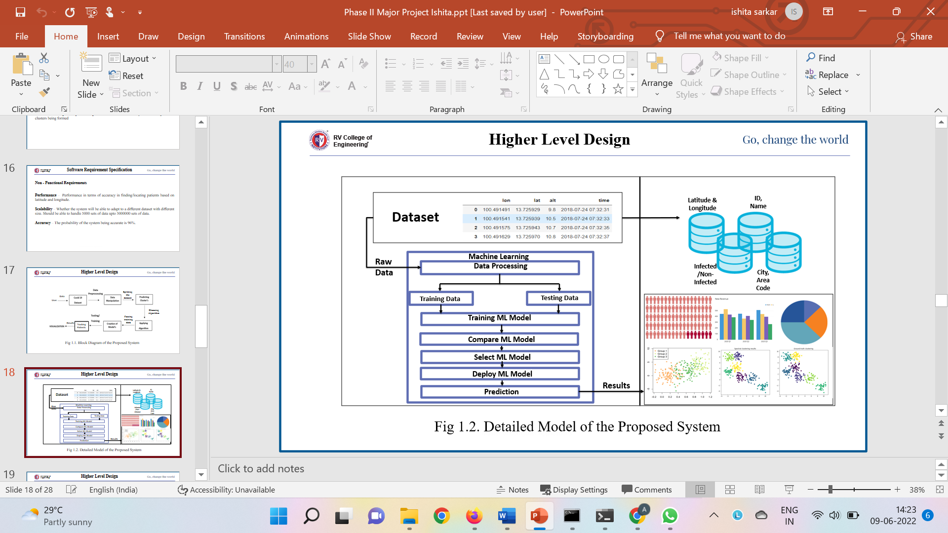

**Fig 4.1 Architecture Diagram**

Fig 4.1 shows the architecture of the proposed structure and how the system is going to be developed. It also shows the different components one to work with to completely built a Contact tracing model.

###### Problem Statement

The health sector is always in need of new technology, whether it's in the shape of gear or software that can do important jobs. When Covid struck, there was no means to fight the disease or even tell if someone was sick or not, which was a critical period for the health domain. During the Covid-19 epidemic, the number of persons infected worldwide increased dramatically, with the majority of those infected coming into touch with people who were already infected or showing symptoms.

###### Block Diagram

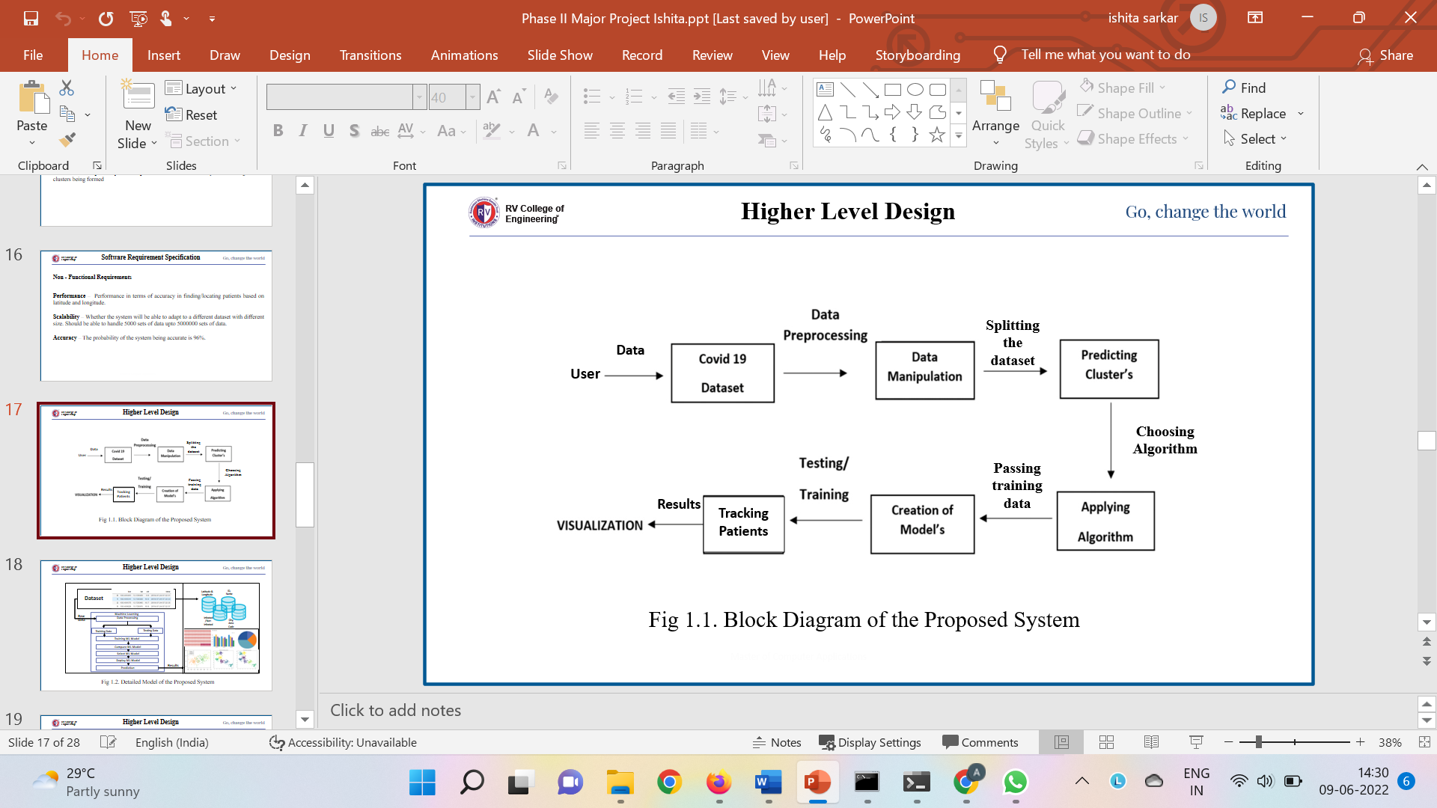

**Fig 4.2 Block Diagram**

Fig 4.2 shows the flow of the request from a user to the providing of patient details. When the service is requested by the user, it is accepted through the model built and the task is further performed to search who is nearest to the location of the patient.

* + 1. **Module Specification**

**Patient Tracking**

Tracking Patient

Tracking Patient’s whereabouts

Location patients using latitude and longitude

###### Infected Patient Diagnosis

Sorting individuals who came in contact with patient

Matching dates with that of patient

Checking whether other people are from the same cluster only

###### Identification of probably infected patients

List of patients who are infected

List of patients not infected

Probability of the non-infected patient of getting infected

**Probability of person getting infected**

Percentage value of the non-infected getting infected

The percentage value should be calculated depending on:

* Whether came in contact with patient or not
* The range of symptoms



##### Context Diagram

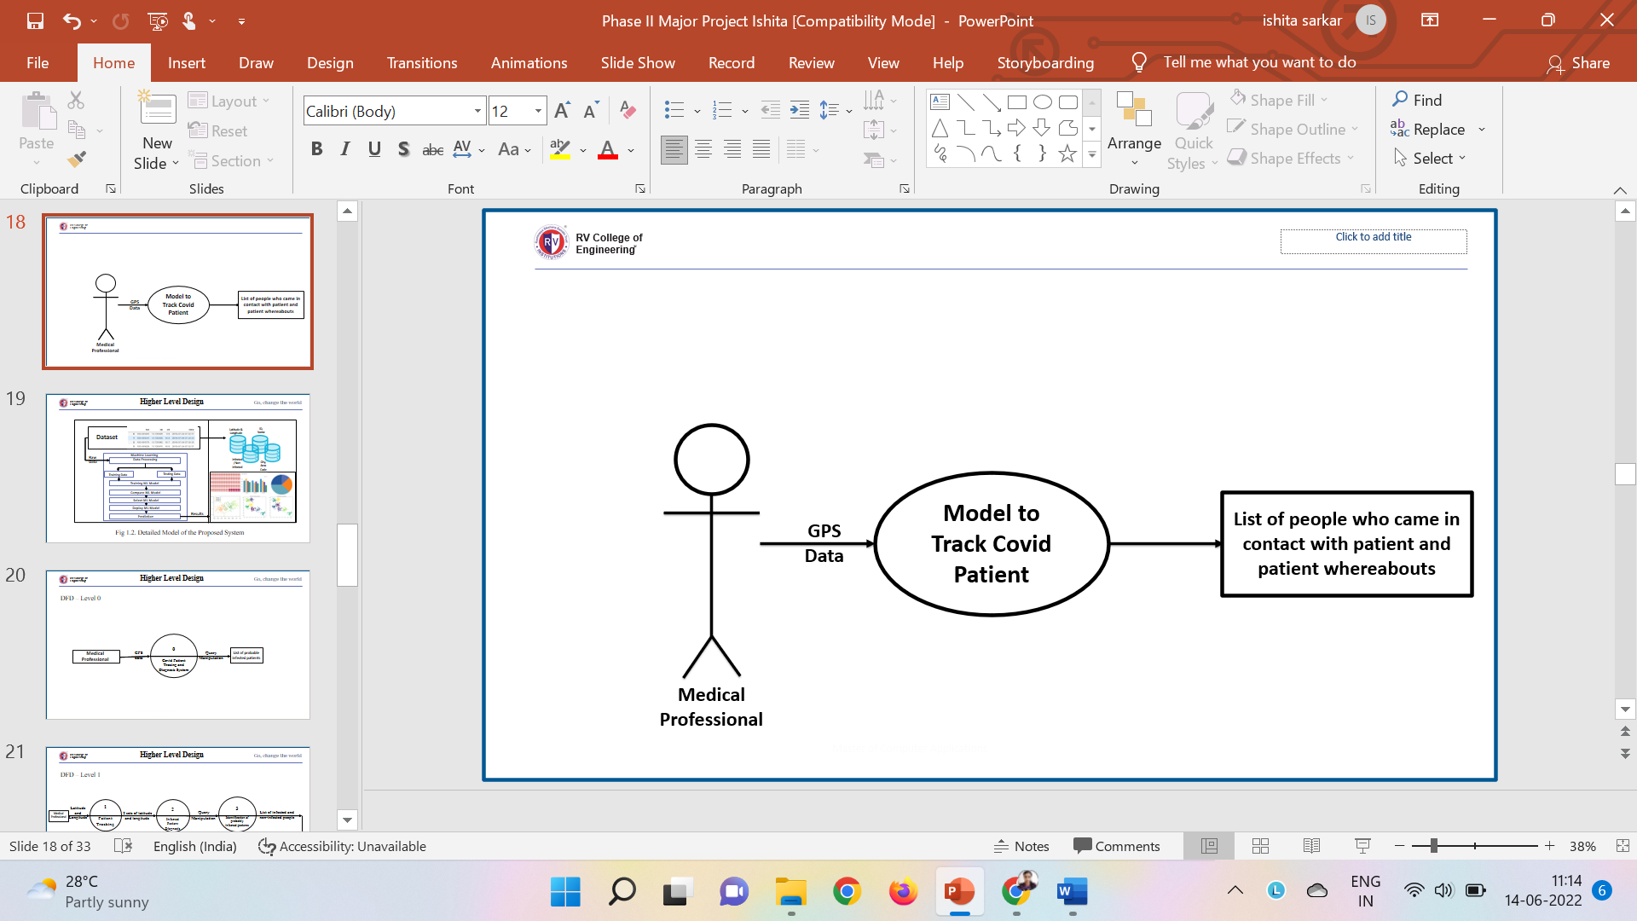

###### Fig 4.3 Context Diagram

Fig 4.3 shows the flow between the components of the system. This is a high-level diagram that shows the internal process that takes place when a user requests a service. The model provides service based on the GPS data passed. Once the data is available the clusters are formed and the model searches for the patient and other individuals.

### CHAPTER 5

### DETAILED DESIGNS

##### System Design

System design administer a sketch and analysis of the system's architecture, including how the system is connected internally, how work flows within the system, and the concept of complete system components.

1. **Dynamic Modelling**
2. 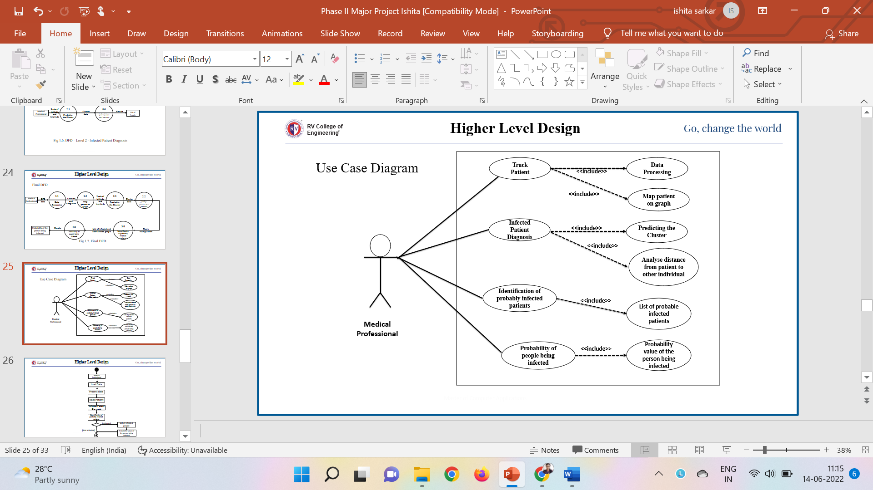**Use Case Diagram**

**Fig 5.1 Use-case Diagram**

Fig 5.1 shows the actor, User, present in the system. The actor has specific functions to perform. The user tracks patients using the GPS data. They further diagnose the infected patient to check for people who came in contact with them. After which it checks among the other individuals who are infected and who aren’t.

1. 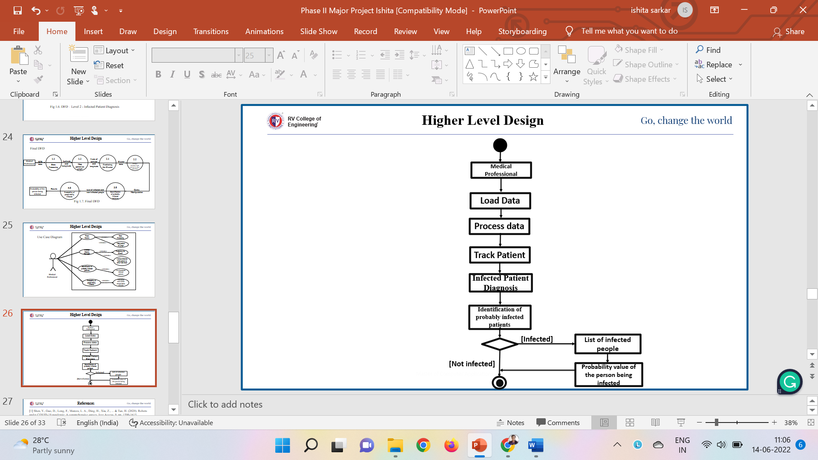**Activity Diagram**

**5.2 Activity Diagram**



Fig 5.2 describes the activities that take place in the system. The activity starts when the User loads the data. After which they form clusters using ML algorithm, once the clusters are formed a random id is chosen and further used for processing.

###### Functional Modelling

* + - 1. **Data Flow Diagram**

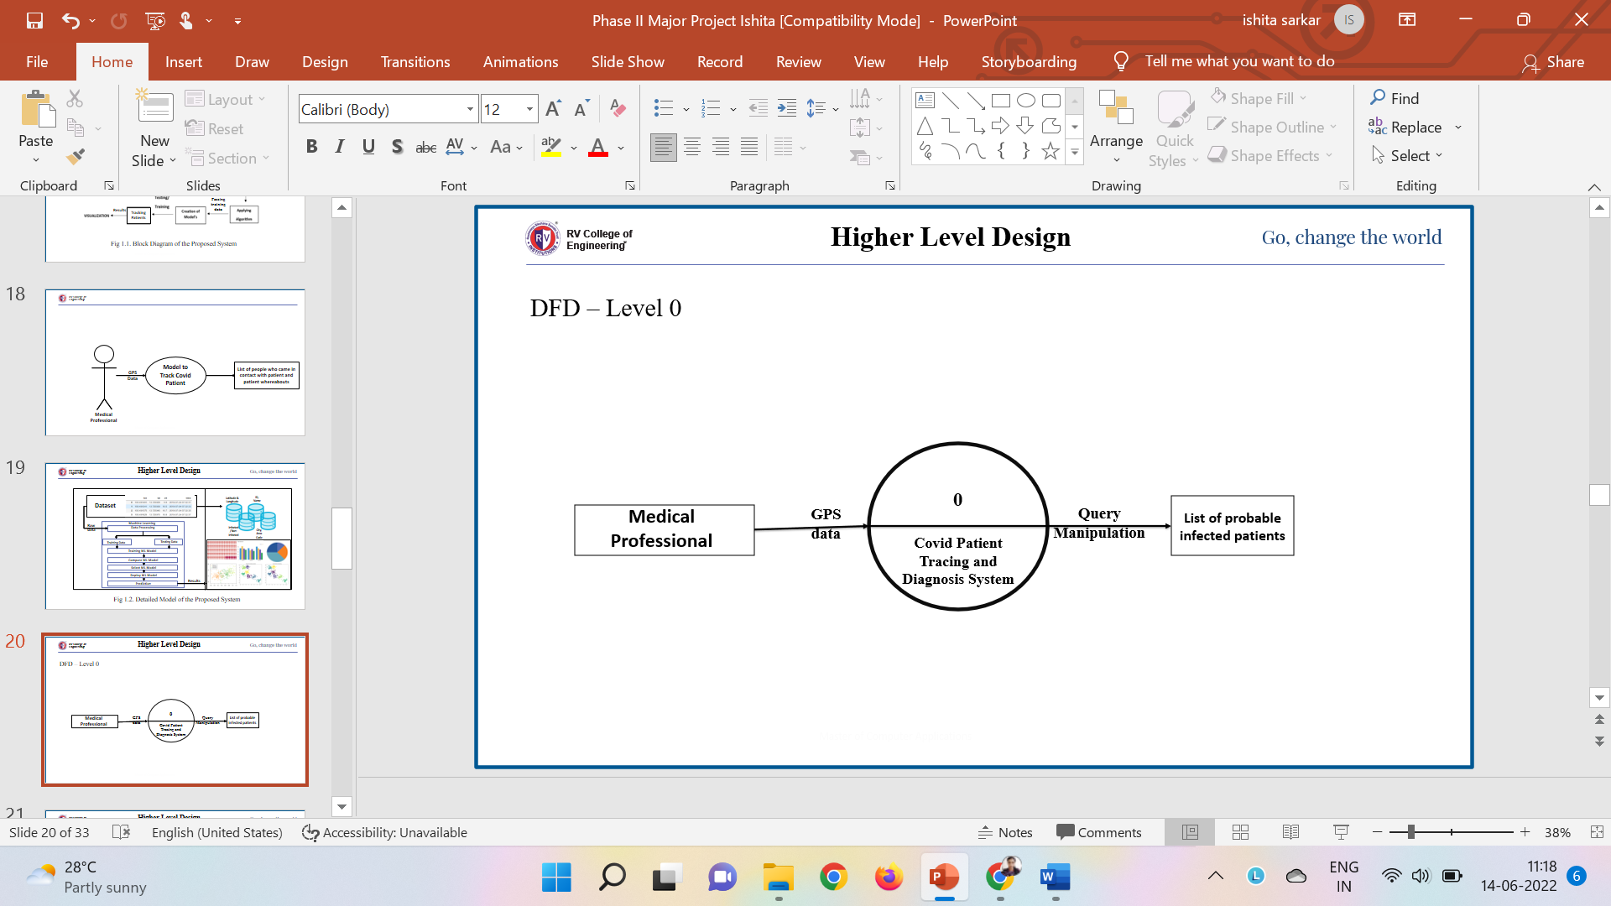***Zero Level DFD***

**Fig 5.3 DFD Level-0**

The fig. 5.3 shows the highest level of the DFD. The process involved when a user requests a patient to be tracked is shown.

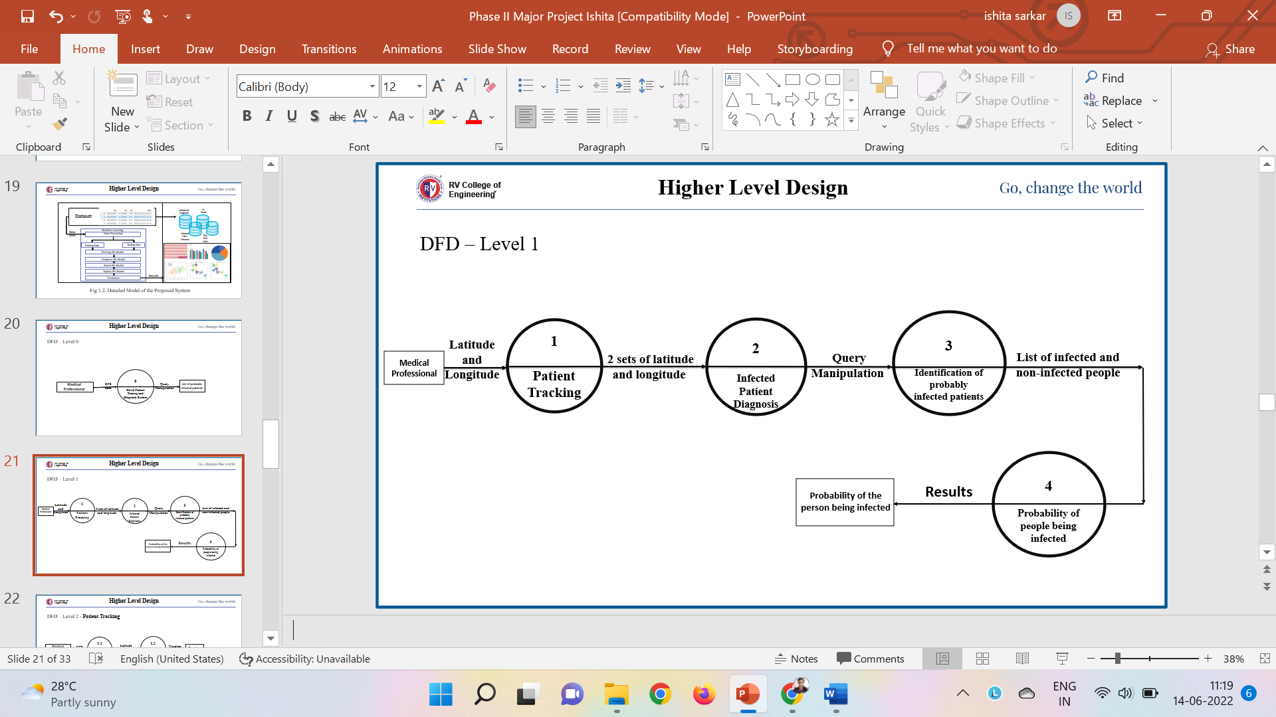***First Level DFD***

**Fig 5.4 DFD Level-1**

The fig. 5.4 shows the data flow between user, track patient, infected patient diagnosis and identification of probable infected patient. When the data is loaded by the user, the details of the patient is taken and the location is tracked. The patient information is transferred to the infected patient diagnosis. Once the patients are recognized the details are sent to the user.

***Second Level DFD***

**Module Name: Patient Tracking**

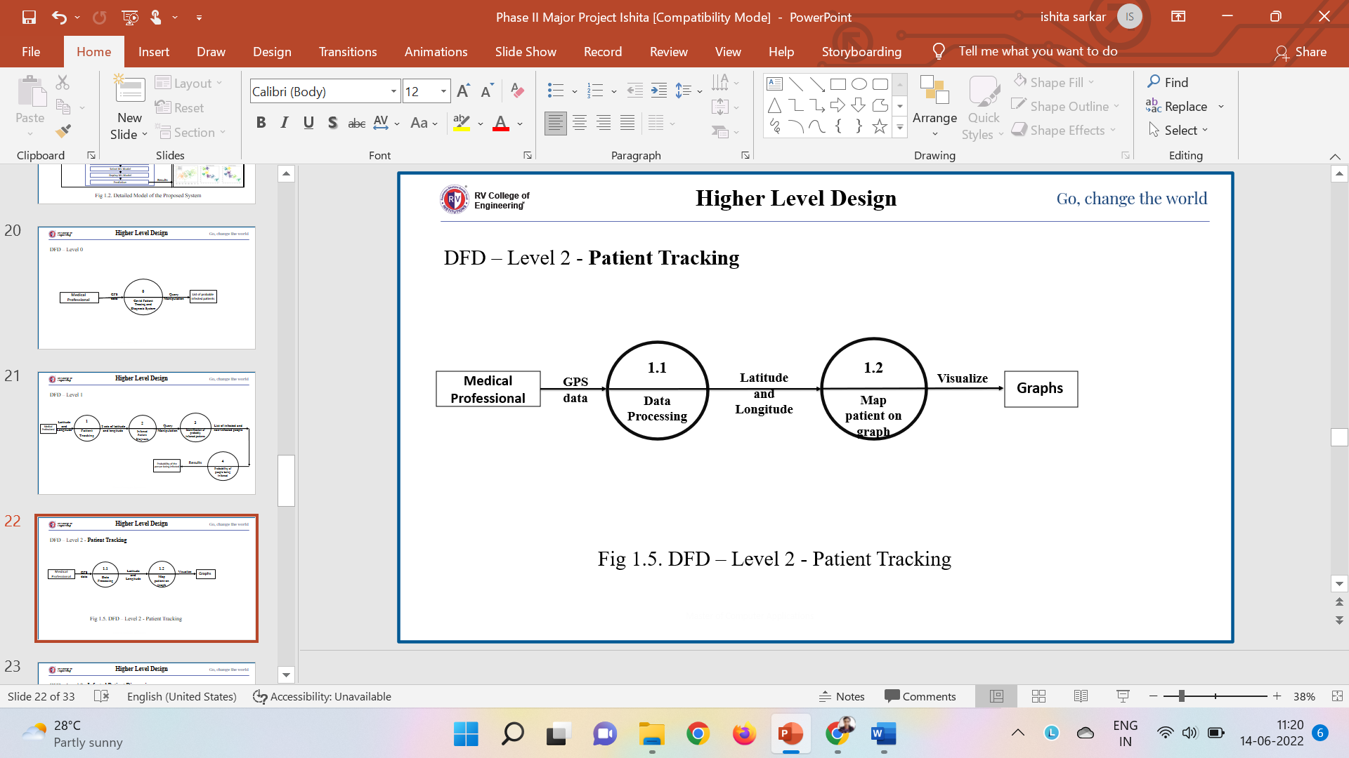

**Fig 5.5 DFD Level-2 Patient Tracking**

**Module Name: Infected Patient Diagnosis**

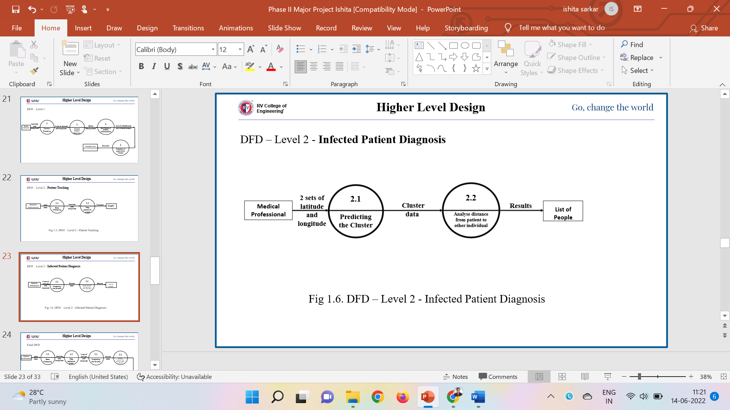

**Fig 5.6 DFD Level-2 Infected Patient Diagnosis**

***Final Level DFD***

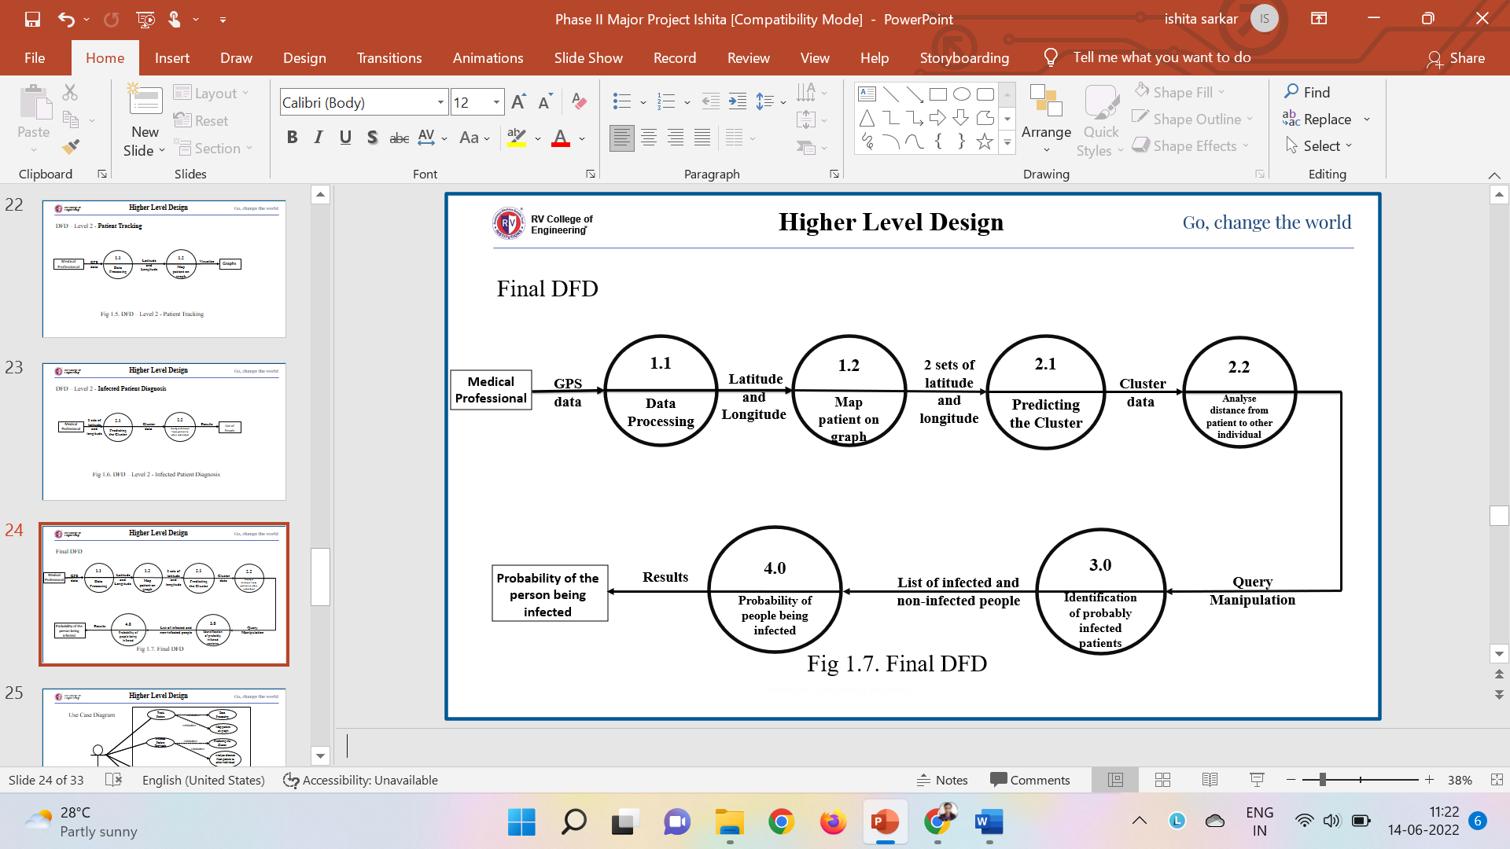

**Fig 5.5 Final DFD**

Fig 5.5 shows the next level of DFD that is the in-depth flow of data that takes place. The data that is flown from the user to the model, from the model to the patient diagnosis, from patient diagnosis to the identifying probable patients.

* + - 1. **Sequence Diagram**

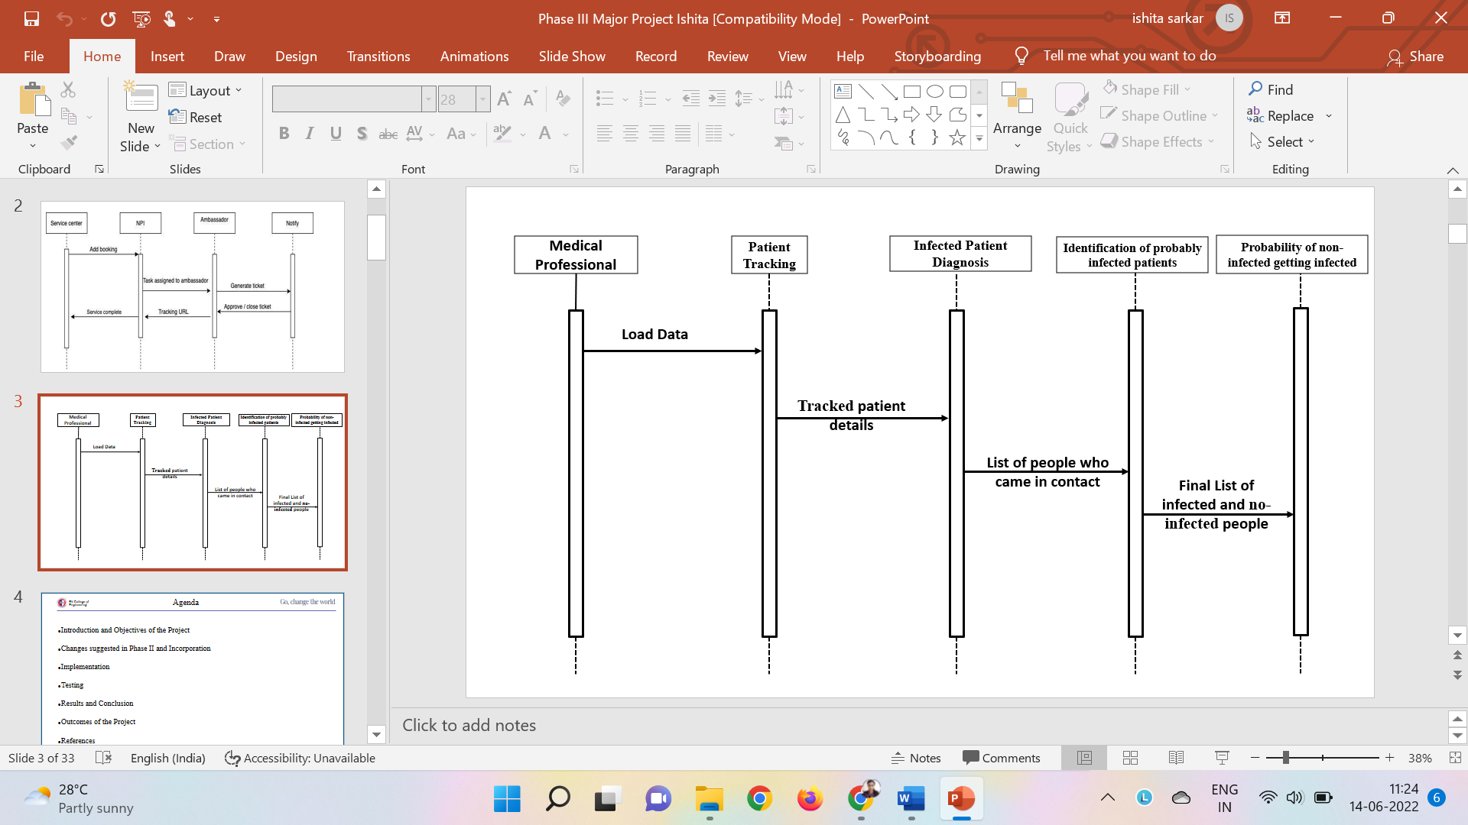

**Fig 5.6 Sequence Diagram**

Fig 5.6 gives a clear description of the data flow inside the Contact Tracing Mode

### CHAPTER 6

### IMPLEMENTATION

##### Code Snippets

**DBSCAN**

safedistance = (0.0018288/6371)

ls=[]

for date in data.Dates.unique():

data1=data[data.Dates==date]

print("Data shape : ",data1.shape[0])

model = dbscan(eps=safedistance, min-samples=2, algorithm='ball-tree', metric='haversine').fit(np.radians(data1[['lat', 'long']]))

core-samples_mask = np.zeros_like(model.labels_, dtype=bool)

core-samples-mask[model.core-sample-indices_] = True

labels = model.labels_

data1['Cluster'] = model.labels_.tolist()

ls.append(data1)

data_final=pd.concat(ls,axis=0)

print("Final data shape : ", data_final.shape)

print (model.labels_)

**Patient Tracking**

# randomly find a number

import random

# random_id=random.randint(data_final1.id.min(),data_final1.id.max())

# random_id=random.choice(data_final1.id.tolist())

random_id=random.choice(data_final1.loc[data_final1.infected==True,'id'].tolist())

#find the cluster where he/she falls

random_id_cluster=data_final1[(data_final1.id==random_id)]

print(f"The random id is : {random_id} and belongs to cluster {random_id_cluster['Cluster'].tolist()[0]}. Name : {random_id_cluster['first_name'].tolist()[0]}. He was present on date {random_id_cluster['Dates'].tolist()[0]}")

**Infected Patient Diagnosis**

cluster_req=data_final.loc[data_final.id==random_id,'Cluster'].tolist()[0]

infected_ids=data_final[(data_final.Dates==random_id_cluster['Dates'].tolist()[0]) & (data_final.Cluster==cluster_req)]

infected_ids

disp-dict={}

lst=[]

for index, row in infected_ids.iterrows():

if row['id'] !=random_id:

lst.append((row['latitude'], row['longitude']))

xy-chart = pygal.XY(stroke=False)#,style=dark-lighten-style)

xy_chart.add(str(random_id_cluster['first_name'].tolist()[0]), [(random_id_cluster['latitude'].tolist()[0], random_id_cluster['longitude'].tolist()[0])])

#other person

xy_chart.add("Infected",lst_infected)

xy_chart.add("Not Infected",lst_not_infected)

displays(HTML(base-html.format(rendered-chart=xy-chart.render(is-unicode=True)

)))

**Identification of probably infected patients**

infected_ids=data_final1[(data_final1.Dates==random_id_cluster['Dates'].tolist()[0]) & (data_final1.Cluster==random_id_cluster['Cluster'].tolist()[0])]

infected_ids

infected_ids=data_final1[(data_final1.Dates==random_id_cluster['Dates'].tolist()[0]) & (data_final1.Cluster==random_id_cluster['Cluster'].tolist()[0]) & (data_final1.infected==False) & (data_final1.id!=random_id)]

infected_ids

infected_ids=data_final1[(data_final1.Dates==random_id_cluster['Dates'].tolist()[0]) & (data_final1.Cluster==random_id_cluster['Cluster'].tolist()[0]) & (data_final1.infected==True) & (data_final1.id!=random_id)]

infected_ids

**Probability of patient getting infected**

cough=int(input("Cough Range : [Enter value between 1 and 5 , 1 being the lowest and 5 being the highest] :"))

fever=int(input("Fever Range : [Enter value between 1 and 5 , 1 being the lowest and 5 being the highest] :"))

breathe=int(input("Breathing Range : [Enter value between 1 and 5 , 1 being the

lowest and 5 being the highest] :"))

infected=input("In contact with infected? (y/n) :")

if infected.lower()=='y':

infected=1

elif infected.lower()=='n':

infected=0

else:

print("Incorrect value entered. Please start again")

if infected==0 or infected==1:

value=(cough+fever+breathe)/3*5

elif infected==1:

value=((cough*2+fever2+breathe2)/(3*5)2)*0.5

print("The severity % is :",value)

[5:57 pm, 09/06/2022] Amar Chokher Bali: cough=int(input("Cough Range : [Enter value between 1 and 5 , 1 being the lowest and 5 being the highest] :"))

fever=int(input("Fever Range : [Enter value between 1 and 5 , 1 being the lowest and 5 being the highest] :"))

breathe=int(input("Breathing Range : [Enter value between 1 and 5 , 1 being the lowest and 5 being the highest] :"))

infected=input("In contact with infected? (y/n) :")

if infected.lower()=='y':

infected=1

elif infected.lower()=='n':

infected=0

else:

print("Incorrect value entered. Please start again")

if infected==0 or infected==1:

value=(cough+fever+breathe)/3*5

elif infected==1:

value=((cough * * 2+fever * * 2+breathe * * 2)/(3 * 5 ) * * 2) * * 0.5

print("The severity % is :",value)

##### Implementation

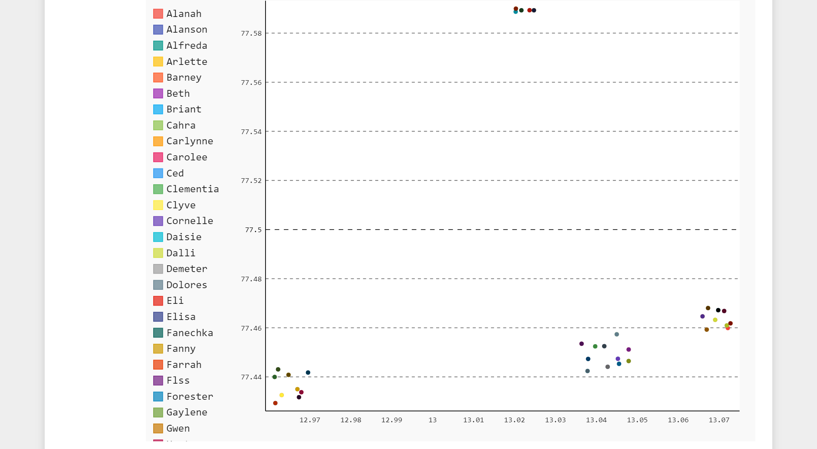

**Fig 6.1 Clusters**

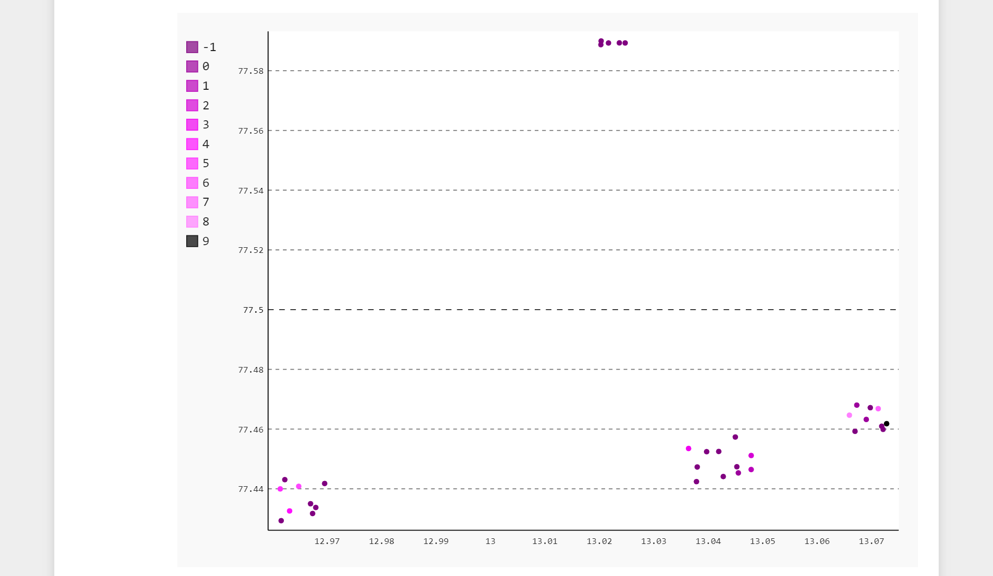

**Fig 6.2 Clusters with noise**

Fig 6.2 shows the clusters with a -1 cluster too which represents the outliers in the dataset and are needed to be removed, the numbers from 0 to 9 represents the clusters one actually need to work with the contact tracing.

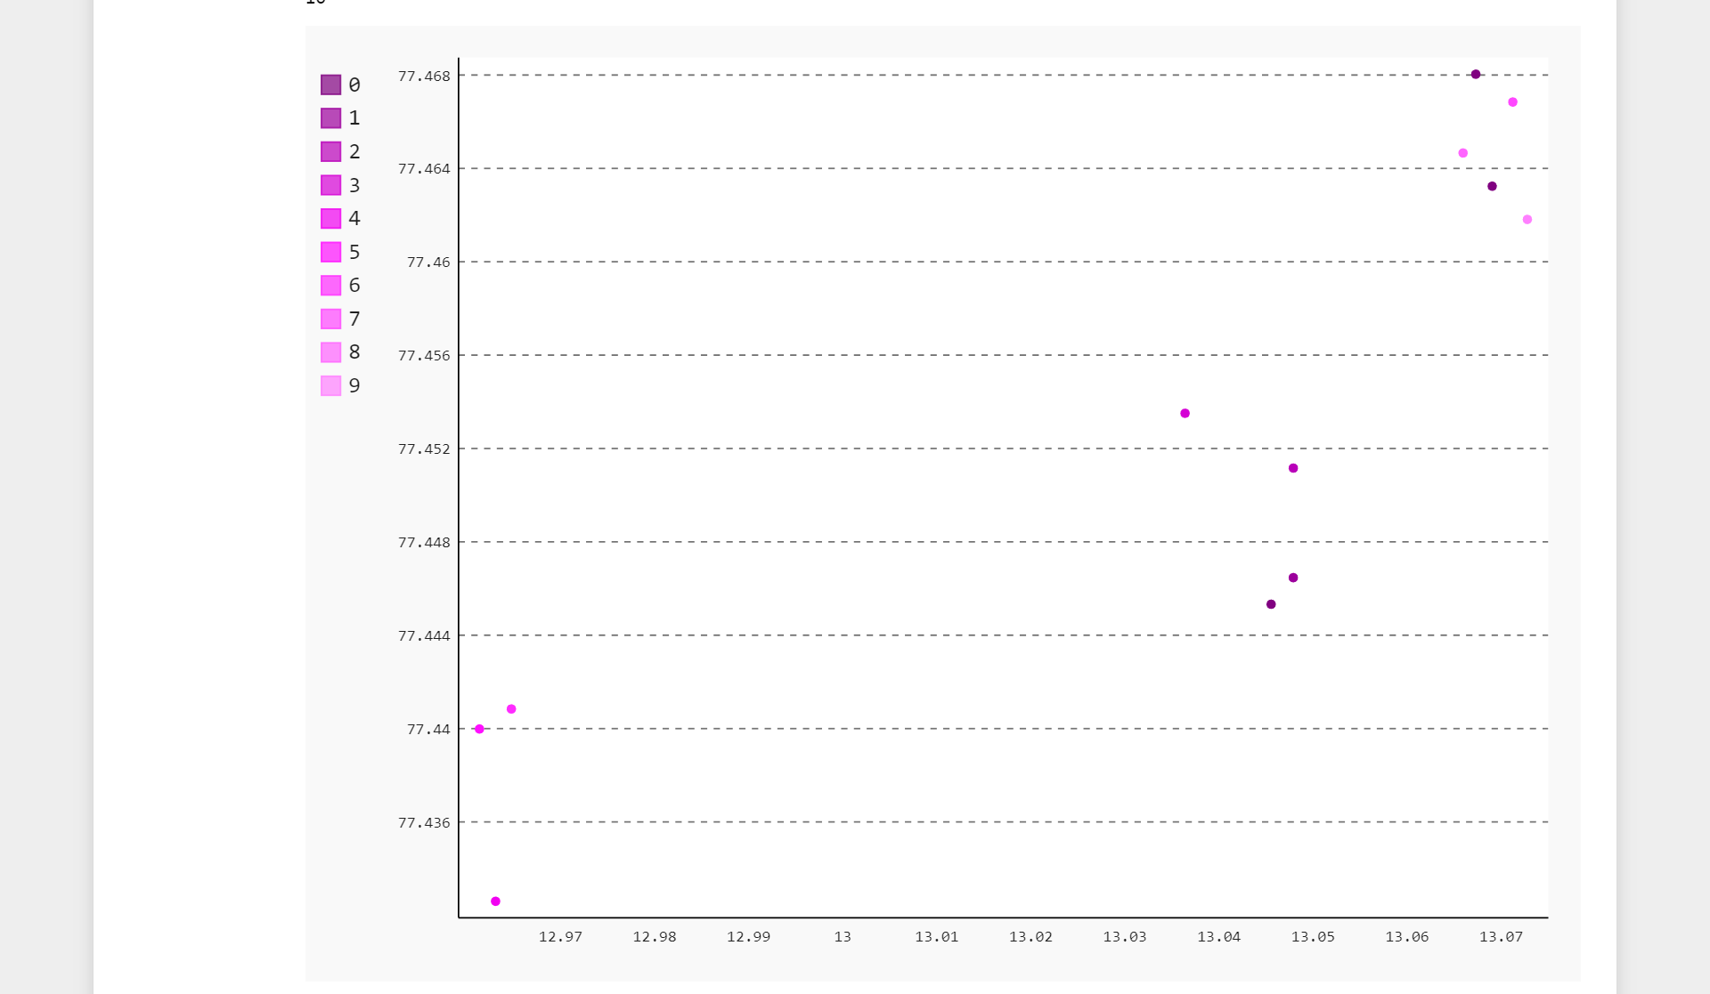

**Fig 6.3 Clusters without noise**

Fig 6.3. shows the final data and clusters without the outliers, thus after removing the -1 cluster the final cluster value is 10.

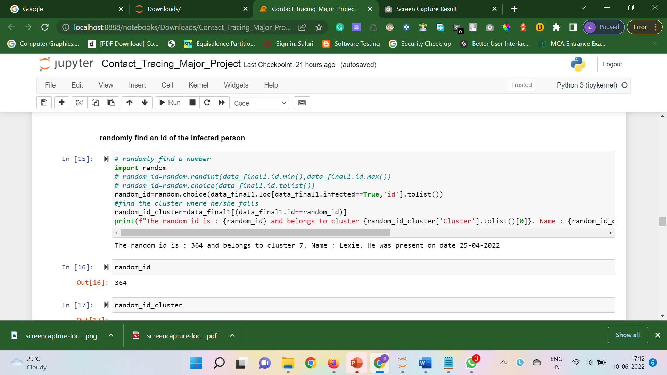

**Fig. 6.4 Choose Random id**

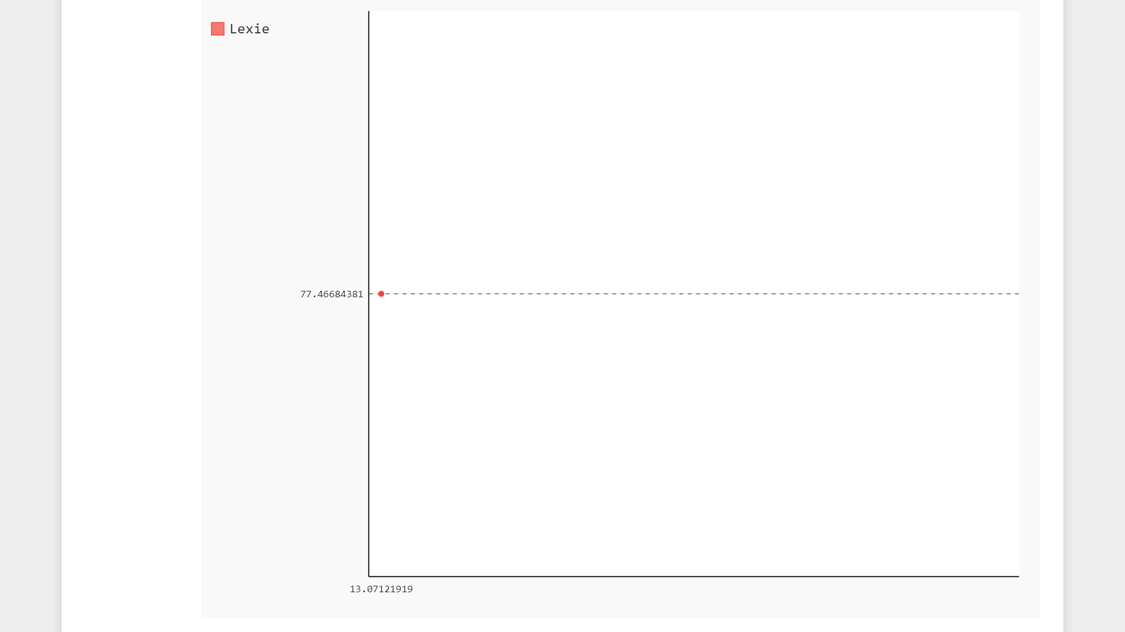

**Fig. 6.5 Plotting single Patient**

Fig 6.5 shows the process of choosing a random patient and plotting that random patient on a graph using latitude and longitude.

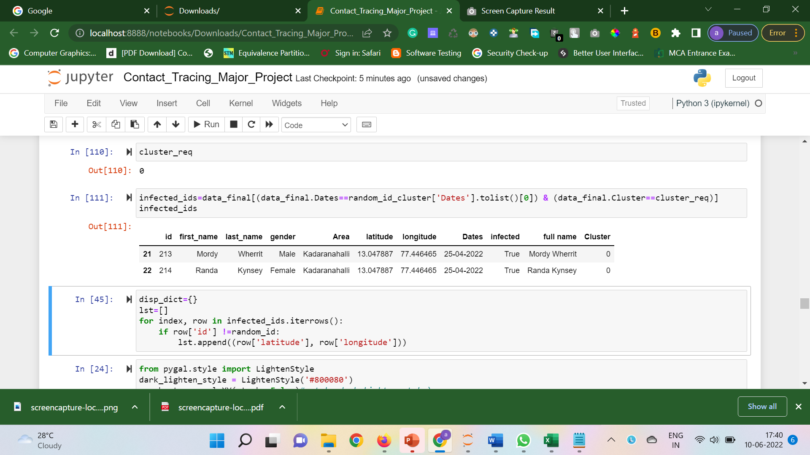

**Fig. 6.6 List of people who came in contact**

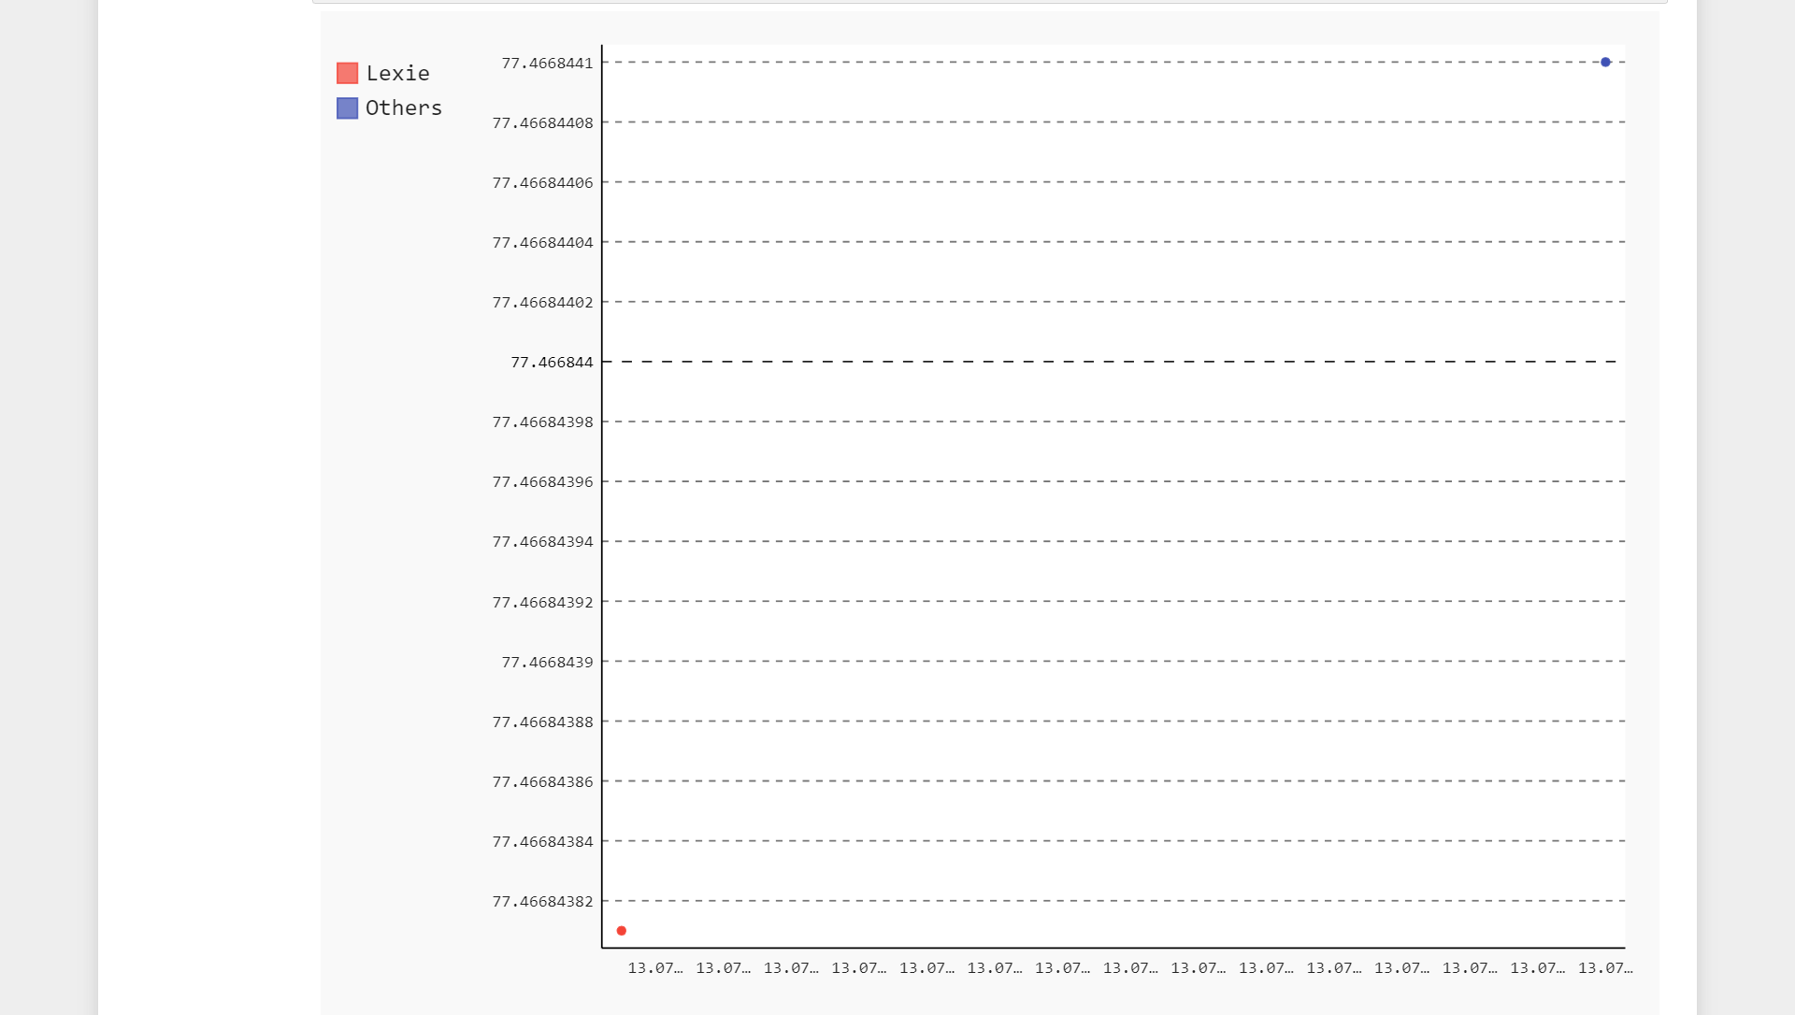

**Fig. 6.7 Plotting newly identified individuals**

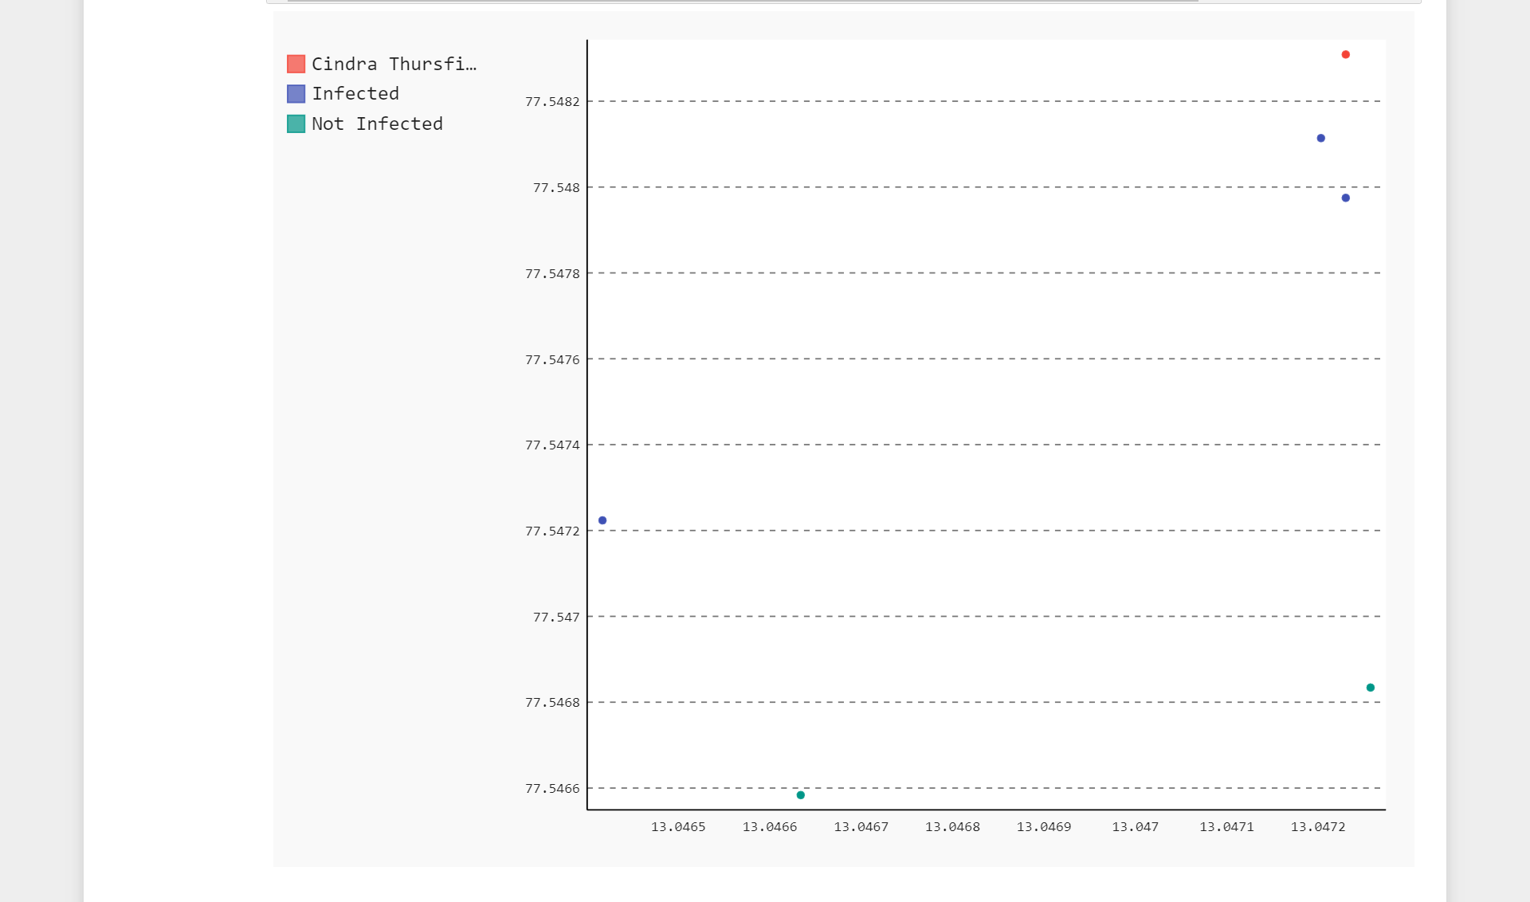

**Fig. 6.8 Plotting infected and non-infected people**

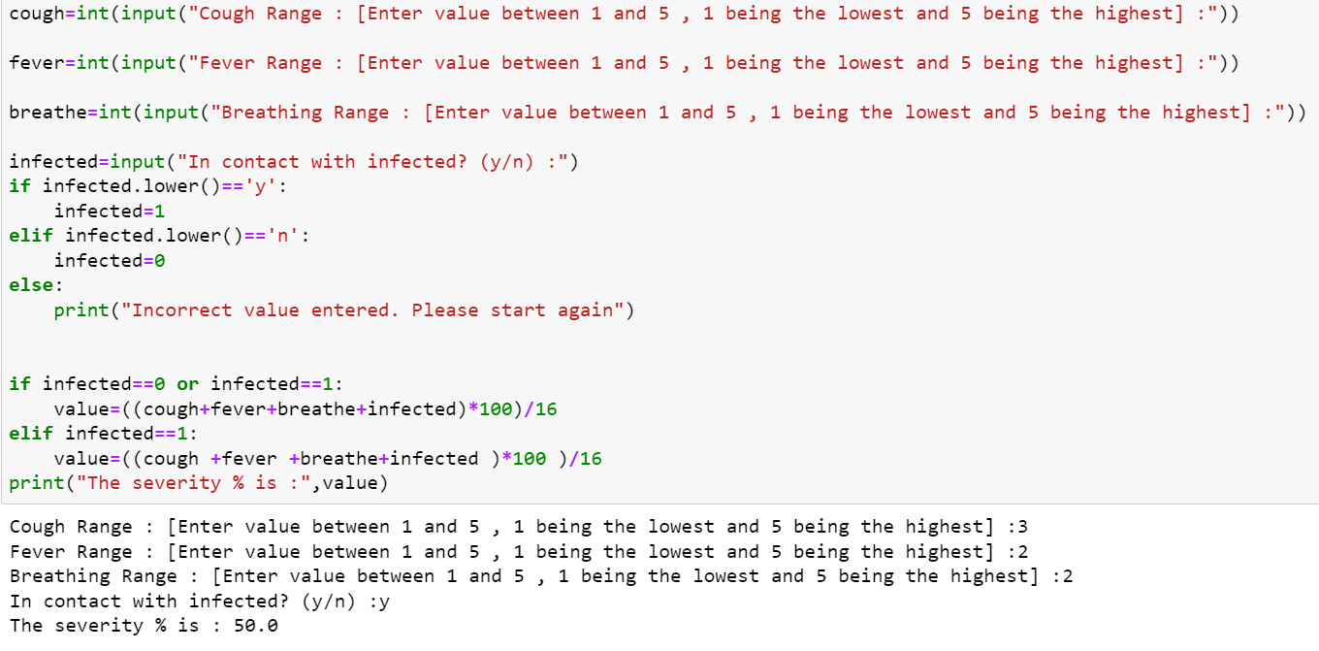

**Fig. 6.8 Probability of a person getting infected**

### CHAPTER 7

### SOFTWARE TESTING

Every business enterprise need to provide number one cognizance to checking out whilst constructing any project. Testing is an crucial part of improvement , specially to make certain quality. Many smaller and mid- sized corporations don’t provide checking out lots interest albeit it’s important for handing over a strong product. Just like it’s crucial to own checks present, it additionally topics how the company run those checks. Every business enterprise growing a product need to have checks present. Testing is an crucial part of improvement , specially to make certain quality. Many smaller and mid- sized corporations don’t provide checking out lots interest albeit it’s important for handing over a strong product. Just like it’s crucial to own checks withinside the specific situation, it additionally topics how the company run those checks. Some corporations prefer to do guide checking out, even though that’s now no longer the handiest approach. The subsequent logical step is automating your checking out technique the business enterprise have checks present. Manual checking out need to be minimized in any respect costs. And take a look at automation will increase average software program improvement performance and lets in for extra strong equipment to be built.The following are examples of the types of testing carried out as part of this project.

###### Unit Testing

Testcases are prepared for each and every feature and the entire flow is tested in such a manner that each and every testcase is passed in each of the cycle so that there is no bugs remaining due to code changes after each cycle,which enables to have a very bug free product after the end of the unit testing.

###### Load Testing

Load testing emphasizes testing of the behaviour of system during the course of load being put on it or computing device can handle high loads given a high demand of end- users.

##### Test Cases

The testing phase of the project consists of unit test cases. Since the modules are independent of each other completely as intermediary outputs are being fed for the next module as input, there is no connection or integration done at a later point of time

.

**7.1: Unit test cases for Extraction of data**

|  |  |  |  |  |  |
| --- | --- | --- | --- | --- | --- |
| **Test Case ID/No.** | **Test Case Description** | **Input/Inputs** | **Expected Outputs** | **Actual Outputs** | **Results** |
| **T01** | Format of dataset dumped by client | "C:\Users\  ISHITA  \Desktop\  Major project\t  estdata01.csv" | {1, Parry Rodolf, Male, Ganganagar, 13.024737, 77.589290, 23-04-2022, True};  {2, Thatch Woolatt, Male, Ganganagar, 13.024737, 77.589290, 23-04-2022, True} | {1, Parry Rodolf, Male, Ganganagar, 13.024737, 77.589290, 23-04-2022, True};  {2, Thatch Woolatt, Male, Ganganagar, 13.024737, 77.589290, 23-04-2022, True} | Pass |
| Dataset in .flv  format | Fail |
| **TO2** | Validation of date format | “23-04-2022” | True/Valid | True/Valid | Pass |
| Any other output | Fail |
| **TO3** | Check if any row is empty | If(row.i==” ”) | Delete the row | Delete the row | Pass |
| Any other output | Fail |

The test cases talk about validating the format of the data sets and location of file which is fetched in notebook. The average number of patient details is generated using Mockroo website where user has to enter the number of required columns and add the parameters as needed then it generates the number of rows with particular dummy data which can used. This results in generating huge data in hundreds of files based on the time period for which the model was getting tested.

Validation of dates is a common scenario where the model can find out the number of individuals who came in proximity with positive patient on the same day. Normalizing them would help the model recognize the data from all the time periods simultaneously that reduces time of execution.

**7.2: Unit test cases for Locating covid patients**

|  |  |  |  |  |  |  |  |  |
| --- | --- | --- | --- | --- | --- | --- | --- | --- |
| **Test Case ID/No.** | **Test Case Description** | | **Input/Inputs** | | **Expected Outputs** | | **Actual Outputs** | **Results** |
| **T01** | Find Infected People using ID | | Person ID=  213 | | 213,Mordy Wherrit, Male, Kadaranahalli, 13.047887, 77.446465,  25-04-2022,  True,0 | | 213,Mordy Wherrit, Male, Kadaranahalli, 13.047887, 77.446465, 25-04-2022, True,0 | Pass |
| Any other output | Fail |
| **TO2** | Find Infected People using Name | | “Randa” | | 214,  Randa Kynsey, Female, Kadaranahalli, 13.047887, 77.446465,  25-04-2022,  True, 0 | | 214, Randa Kynsey, Female, Kadaranahalli, 13.047887, 77.446465, 25-04-2022, True, 0 | Pass |
| Any other output | Fail |
| **T03** | | Find Infected  People using Date | | “4-9-2021” | | {213, Mordy Wherrit, Male, Kadaranahalli, 13.047887, 77.446465, 25-04-2022, True, 0};{ 214, Randa Kynse, Female, Kadaranahalli, 13.047887, 77.446465, 25-04-2022,True, 0} | {213, Mordy Wherrit, Male, Kadaranahalli, 13.047887, 77.446465, 25-04-2022, True, 0};{ 214, Randa Kynse, Female, Kadaranahalli, 13.047887, 77.446465, 25-04-2022,True, 0} | Pass |
| Any other output | Fail |

The Unit test cases for Locating covid patients talk about tracing the particular individual positive patient with inserting few unique values as patient id or name as a input. The details of covid positive patient will be displayed with location as in dataset it has mentioned about the coordinates

with place name also dataset contains the dates of the particular patient on which date he was present on which location, which gives us clear picture to figure out the covid infected and non-infected people.

**7.3: Unit test cases for Locate people who came in contact with the infected patient**

|  |  |  |  |  |  |  |
| --- | --- | --- | --- | --- | --- | --- |
| **Test Case ID/No.** | **Test Case Description** | **Input/**  **Inputs** | **Expected Outputs** | **Actual Outputs** | **Remarks** | |
| **T01** | checking People in radius with infected person | “4-6-2022” | “Danish, male, infected;  Akanksha, female, non-infected; Alok, male, non-infected” | “Danish, male, infected;  Akanksha, female, non-infected; Alok, male, non-infected” | Pass | |
| Any other output | Fail | |
| **T02** | Checking People in same clusters with infected person | Cluster=2 | “Vimal, male,2;Tanisha,female,2” | “Vimal, male,2;Tanisha,female,2” | Pass | |
| Any other output | Fail | |
| **T03** | Finding People in same city | “Bengaluru” | {“Lalith,male,23,  Bengaluru”;  ”Arav,male,34,  Bengaluru”} | {“Lalith,male,23,  Bengaluru”;  ”Arav,male,34,  Bengaluru”} | Pass |
| Any other output | Fail |

The Unit test cases for Locate people who came in contact with the infected patient talk about tracing the particular individual people who has been in contact with positive patient within the given radius mentioned (**i.e., 0.0001876**) in eps value in algorithm where it defines the neighborhood around the single data point i.e. so if the distance between 2 points is less than or equal to ‘eps’ then they are considered as neighbors and **MinPts which counts** the **Minimum number of neighbors (data points) within the eps radius/range. Larger the dataset, the larger value of MinPts must be chosen by the user.** The cluster is formed based on the DBSCAN algorithm where it basically focus on Density-based clustering along with noise clustering method, also to find number of infected through clusters are one of the technique. Dataset contains the name of the cities through which one can detect the number of infected or non-infected people around the city.

**Table 7.4: Unit test cases for check if other people located were covid infected or not**

|  |  |  |  |  |  |
| --- | --- | --- | --- | --- | --- |
| **Test Case ID/No.** | **Test Case Description** | **Input/Inputs** | **Expected Outputs** | **Actual Outputs** | **Results** |
| **T01** | Find infected people in contact | 0,  25-4-2022” | 214, Randa Kynsey, Female,  Kadaranahalli, 13.047887, 77.446465, 25-04-2022, True, 0 | 214, Randa Kynsey, Female,  Kadaranahalli, 13.047887, 77.446465, 25-04-2022, True, 0 | Pass |
| Any other output | Fail |
| **T02** | Find non-infected people in contact | 1, Ganganagar | 3,Lazare Moryson,  Male,  Ganganagar, 13.023669, 77.589321,23-04-2022, False, 1 | 3,Lazare Moryson,  Male,  Ganganagar, 13.023669, 77.589321,23-04-2022, False, 1 | Pass |
| Any other output | Fail |
| **T03** | Graph the identified people | {214, Randa Kynsey, Female,  Kadaranahalli, 13.047887, 77.446465, 25-04-2022, True, 0};{3,Lazare Moryson,  Male,  Ganganagar, 13.023669, 77.589321,23-04-2022, False, 1} |  |  | Pass |
| Any other output | Fail |

The Unit test cases for check if other people located were covid infected or not and its results, tracing the particular individual people who has infected or not followed by count of infected people and count of non-infected people based on

the certain parameters. It can be based on city where the input will be city name and the list of people infected or non-infected will be displayed and second method is based on dates which can find out the infected or non-infected person

with respective to city. The other method followed will be through clusters where the count of infected and non-infected in same clusters can be displayed or respective other clusters based on safe distance mentioned, if the person is in under mentioned distance will be counted as infected vise-versa.

**Table 7.5: Unit test cases to check if the probability value predicted is correct**

|  |  |  |  |  |  |
| --- | --- | --- | --- | --- | --- |
| **Test Case ID/No.** | **Test Case Description** | **Input/Inputs** | **Expected Outputs** | **Actual Outputs** | **Results** |
| **T01** | Find probability | 35 | 50% | 50% | Pass |
| Any other output | Fail |
| **T02** | Check if infected value taken is correct or not | ‘y’ | Proceed further | Proceed further | Pass |
| Any other output | Fail |
| **T03** | Check symptom range is within expected limit | Cough  Range : 3 | Proceed further | Proceed further | Pass |
| Any other output | Fail |

The Unit test cases for check if the probability value predicted is correct and it’s results. One can observe that if the values of person came in contact is anything else than ‘n’ or ‘y’ the model won’t be able to predict the values correctly and will predict some incorrect value. Not only that the patient id should also be entered correctly otherwise the percentage value will not be correct.

### CHAPTER 8

### CONCLUSION

The COVID-19 epidemic continues to have an impact on everyone's way of living. Contact tracing is anticipated to be crucial in aiding health officials in promptly spotting those who may have been exposed to the virus. COVID-19 has made a terrible impact on human existence around the world, it has severely impacted the management of educational institutions and workplaces, as well as many other areas of daily life as one knows it.

Thus, from the preceding sections that a clustering technique like DBSCAN can cluster data points from the dataset without having previous knowledge of number of clusters being formed. Thus, DBSCAN is effective in finding non-linearly separable clusters, on the other hand clustering algorithms like k-means are insufficient for this kind of dataset. The DBSCAN function is implemented in this project has three objectives where it finds the infected person, the people who came in contact with infected patient followed with the list of infected people and non-infected people based on the same dates and clusters they fall into. Thus, giving us an effective way of tracking down potentially infected individuals. Both digital contact tracing and manual approaches have their own limitations. However, employing machine learning to perform effective contact tracing can help us save on an array of human and financial resources and errors. Finally, one can conclude that the developed system was able to achieve an accuracy of 80-90% while detecting the probability of the non-infected people.

### 

### CHAPTER 9

### FUTURE ENHANCEMENTS

The current COVID-19 outbreak has sparked a widespread adoption of a virus tracking app. If these models and technologies had been in existence and extensively tested before to the commencement of the Covid-19 pandemic, one could have been better prepared for a pandemic of this magnitude.

1. Improvement in proximity accuracy:

In previous exchanges, the current issues with contiguity accuracy were discussed. The Bluetooth technology was not created with location or proximity determination as a primary consideration. During the development phase of new "Bluetooth-like" protocols, a focus on location/proximity services should be prioritized. This approach should include antenna design, which allows for not only distance precision but also direction-finding. The Bluetooth 5.1 protocol does include direction-finding, albeit with limited precision. At the time of writing, no Covid-19 tracing program has such direction capabilities built into their contiguity analysis.

1. A fully decentralized architecture for infection tracing:

One of the "takeaways" from the COVID19 disaster is that the privacy concerns should be superscribe in order for the public to use the technology more widely. None of the apps that is been discussed so far have a fully disseminated design; they all rely on a central server to some extent, usually under the direction of a governing dominion. It is necessary to conduct research on a fully disseminated system that uses some type of peer-to-peer network to permit privacy-preserving information sharing among user-devices.

1. Quantum communications:

At least in terms of deployment, the most newfangled of all the new quantum applications. Commercial quantum communications services are currently available, and prototype deployment in space has already taken place. The newfangled communications security and intensified privacy protections offered by this technology will most likely have the greatest impact on tracing applications. In theory, if properly implemented, future virus-tracking programs will have unrestricted security and privacy, making hacking and unaccredited access to virus-tracking data outdated.

### BIBLIOGRAPHY

1. Rustam, Furqan, Aijaz Ahmad Reshi, Arif Mehmood, Saleem Ullah, Byung-Won On, Waqar Aslam, and Gyu Sang Choi. "COVID-19 future forecasting using supervised machine learning models." IEEE access 8 (2020): 101489-101499
2. Gambhir, E., Jain, R., Gupta, A. and Tomer, U., 2020, September. Regression analysis of COVID-19 using machine learning algorithms. In 2020 International conference on smart electronics and communication (ICOSEC) (pp. 65-71). IEEE.Wala, T. & Sharma, A. K. (2014). Improvised Software Testing Tool, 3(9), 573–581
3. Sarwar, M.A., Kamal, N., Hamid, W. and Shah, M.A., 2018, September. Prediction of diabetes using machine learning algorithms in healthcare. In 2018 24th international conference on automation and computing (ICAC) (pp. 1-6). IEEE
4. Dahiwade, D., Patle, G., & Meshram, E. (2019, March). Designing disease prediction model using machine learning approach. In 2019 3rd International Conference on Computing Methodologies and Communication (ICCMC) (pp. 1211-1215). IEEE
5. Subudhi, S., Verma, A., Patel, A. B., Hardin, C. C., Khandekar, M. J., Lee, H., ... & Jain, R. K. (2021). Comparing machine learning algorithms for predicting ICU admission and mortality in COVID-19. NPJ digital medicine, 4(1), 1-7
6. John, Christopher Clement, Vijayakumar Ponnusamy, Sriharipriya Krishnan Chandrasekaran, and R. Nandakumar. "A survey on mathematical, machine learning and deep learning models for COVID-19 transmission and diagnosis." IEEE reviews in biomedical engineering (2021)
7. Sujath, R., Jyotir Moy Chatterjee, and Aboul Ella Hassanien. "A machine learning forecasting model for COVID-19 pandemic in India." Stochastic Environmental Research and Risk Assessment 34, no. 7 (2020): 959-972
8. Gupta, Rajan, Manan Bedi, Prashi Goyal, Srishti Wadhera, and Vaishnavi Verma. "Analysis of COVID-19 tracking tool in India: case study of Aarogya Setu mobile application." Digital Government: Research and Practice 1, no. 4 (2020): 1-8
9. Berglund, Jennifer. "Tracking COVID-19: there’s an App for that." IEEE pulse 11, no. 4 (2020): 14-17
10. Sandeepa, Chamara, Charuka Moremada, Nadeeka Dissanayaka, Tharindu Gamage, and Madusanka Liyanage. "Social interaction tracking and patient prediction system for potential COVID-19 patients." In 2020 IEEE 3rd 5G World Forum (5GWF), pp. 13-18. IEEE, 2020
11. Mallik, Ranajoy, Dilip Sing, and Rajib Bandyopadhyay. "GPS tracking app for police to track ambulances carrying COVID-19 patients for ensuring safe distancing." Transactions of the Indian National Academy of Engineering 5, no. 2 (2020): 181-185.
12. Biswas, Suparna, et al. "GPS tracking, QR code scanner based application to help the health workers and common citizens during Covid-19." Journal of Physics: Conference Series. Vol. 1797. No. 1. IOP Publishing, 2021
13. Bodas, M. & Peleg, K. Self-isolation compliance in the COVID-19 era influenced by compensation: findings from a recent survey in Israel. Health Aff. (Project Hope) 39, 936–941, 2020
14. Rizzo, E. COVID-19 contact tracing apps: the “elderly paradox’’. Public Health 185, 127,2020
15. Huang, L. *et al.* Rapid asymptomatic transmission of COVID-19 during the incubation period demonstrating strong infectivity in a cluster of youngsters aged 16–23 years outside Wuhan and characteristics of young patients with COVID-19: a prospective contact-tracing study. *J. Infect.* **80**, e1–e13,2020.
16. Lauer, S. A. et al. The incubation period of coronavirus disease 2019 (COVID-19) from publicly reported confirmed cases: estimation and application. Ann. Intern. Med. 172, 577–582,2020
17. Davies, N. G. et al. Age-dependent effects in the transmission and control of COVID-19 epidemics
18. Barabási, A.-L. & Albert, R. Emergence of scaling in random networks. Science 286, 509–512,2020
19. Nielsen, B. F., Sneppen, K., Simonsen, L. & Mathiesen, J. Heterogeneity is essential for contact tracing,2020
20. Braithwaite, I., Callender, T., Bullock, M. & Aldridge, R. W. Automated and partly automated contact tracing: a systematic review to inform the control of COVID-19. Lancet Dig. Health 2, e607–e621,2020
21. Sweeney, Y. Tracking the debate on COVID-19 surveillance tools. Nat. Mach. Intell. 2, 301–304,2020
22. Hellewell, J. et al. Feasibility of controlling COVID-19 outbreaks by isolation of cases and contacts. Lancet Glob. Health 8, e488–e496,2020
23. Tong, Z.-D. et al. Potential presymptomatic transmission of SARS-CoV-2, Zhejiang Province, China, 2020. Emerg. Infect. Dis. 26, 1052–1054,2020
24. Bai, Y. et al. Presumed asymptomatic carrier transmission of COVID-19. JAMA 323, 1406,2020
25. Gandhi, M., Yokoe, D. S. & Havlir, D. V. Asymptomatic transmission, the Achilles’ heel of current strategies to control Covid-19. *N. Engl. J. Med.* **382**, 2158–2160,2020
26. Lavezzo, E. *et al.* Suppression of COVID-19 outbreak in the municipality of Vo, Italy,2020
27. Hellewell J, Abbott S, Gimma A, et al. Feasibility of controlling COVID-19 outbreaks by isolation of cases and contacts. The Lancet Global health. 2020;8:e488–e496
28. Partners In Health to Help State Trace Contacts of COVID-19 Patients in Landmark Agreement with MA Gov's Office
29. Farrahi K, Emonet R, Cebrian M. Epidemic contact tracing via communication traces. PLoS One. 2014;9:e95133
30. Kretzschmar ME, Rozhnova G, Bootsma MCJ, van Boven M, van de Wijgert JHHM, Bonten MJM. Impact of delays on effectiveness of contact tracing strategies for COVID-19: a modelling study. Lancet Public Health. 2020;5:E452–E459
31. Malik, V. & Gahlan, M. (2016). Comparative Study of Automated Web Testing Baxter S, Goyder E, Chambers D, Johnson M, Preston L, Booth A. NIHR Journals Library; Southampton (UK): 2017. Interventions to improve contact tracing for tuberculosis in specific groups and in wider populations: an evidence synthesis
32. Saurabh S, Prateek S. Role of contact tracing in containing the 2014 Ebola outbreak: a review. Afr Health Sci. 2017;17:225–236
33. Gos, Konrad & Zabierowski, Wojciech. (2020). The Comparison of Microservice and Monolithic Architecture 150-153.
34. Lauer SA, Grantz KH, Bi Q, et al. The incubation period of coronavirus disease 2019 (COVID-19) from publicly reported confirmed cases: estimation and application. Ann Intern Med. 2020;172:577–582
35. World Health Organization . 2015. Contact tracing during an outbreak of Ebola virus disease; pp. 1–36
36. Harris PA, Taylor R, Thielke R, Payne J, Gonzalez N, Conde JG. Research electronic data capture (REDCap)-A metadata-driven methodology and workflow process for providing translational research informatics support. J Biomed Inform. 2009;42:377–381
37. Skochelak SE, Hawkins RE, Lawson LE, Starr SR, Borkan J, Gonzalo JD. 1st ed. Elsevier; 2017. Health Systems Science
38. Carlson S, Gonzalo J, Hammound MM, Havemann C, Lomis KD. American Medical Association Innovations in Medical Education Webinar Series; 2020. Deploying Students in alternative roles during COVID-19: Preserving clinical educational objectives and supporting competency development
39. Watson C, Cicero A, Blumenstock J, Fraser M. *Center for Health Security.* 2020. A National Plan to Enable Comprehensive COVID-19 Case Finding and Contact Tracing in the US; pp. 1–16
40. Whelan A, Prescott M, Young G, Catanese VM, Mckinney R. Association of American Medical Colleges; 2020. Guidance on Medical Students’ Participation in Direct Patient Contact Activities; pp. 1–6
41. Mass.Gov. 2020. Baker-Polito Administration Announces COVID-19 Community Tracing Collaborative to Further Mitigate the Spread of Virus [press release]
42. Westervelt E. San Francisco Ramps Up Back-To-Basics Contact Tracing To Stop COVID-19. National Public Radio. Published April 16, 2020
43. Dhillon RS, Srikrishna D. When is contact tracing not enough to stop an outbreak? Lancet Infect Dis. 2018;18:1302–1304
44. Ng Y, Li Z, Chua YX, et al. Evaluation of the Effectiveness of Surveillance and Containment Measures for the First 100 Patients with COVID-19 in Singapore - January 2-February 29, 2020. MMWR Morb Mortal Wkly Rep. 2020;69:307–311
45. Bi Q, Wu Y, Mei S, et al. Epidemiology and transmission of COVID-19 in 391 cases and 1286 of their close contacts in Shenzhen, China: a retrospective cohort study [published correction appears in Lancet Infect Dis. 2020 Jul;20(7):e148] Lancet Infect Dis. 2020;20:911–919
46. Pung R, Chiew CJ, Young BE, et al. Investigation of three clusters of COVID-19 in Singapore: implications for surveillance and response measures. Lancet. 2020;395:1039–1046
47. Macke BA, Maher JE. Partner notification in the United States: an evidence-based review. Am J Prev Med. 1999;17:230–242
48. Glasser JW, Hupert N, McCauley MM, Hatchett R. Modeling and public health emergency responses: lessons from SARS. Epidemics. 2011;3:32–37
49. Ki HK, Han SK, Son JS, Park SO. Risk of transmission via medical employees and importance of routine infection-prevention policy in a nosocomial outbreak of Middle East respiratory syndrome (MERS): a descriptive analysis from a tertiary care hospital in South Korea. *BMC Pulm Med.*2019;19:190
50. Fox GJ, Barry SE, Britton WJ, Marks GB. Contact investigation for tuberculosis: a systematic review and meta-analysis [published correction appears in Eur Respir J. 2015 Aug;46(2):578] Eur Respir J. 2013;41:140‐156
51. Lalvani A, Pathan AA, Durkan H, et al. Enhanced contact tracing and spatial tracking of Mycobacterium tuberculosis infection by enumeration of antigen-specific T cells. *Lancet.*2001;357:2017‐2021
52. Simmons-Duffin S, Stein R. CDC Director: 'Very Aggressive' Contact Tracing Needed For U.S. To Return To Normal. National Public Radio. Published April 10, 2020.

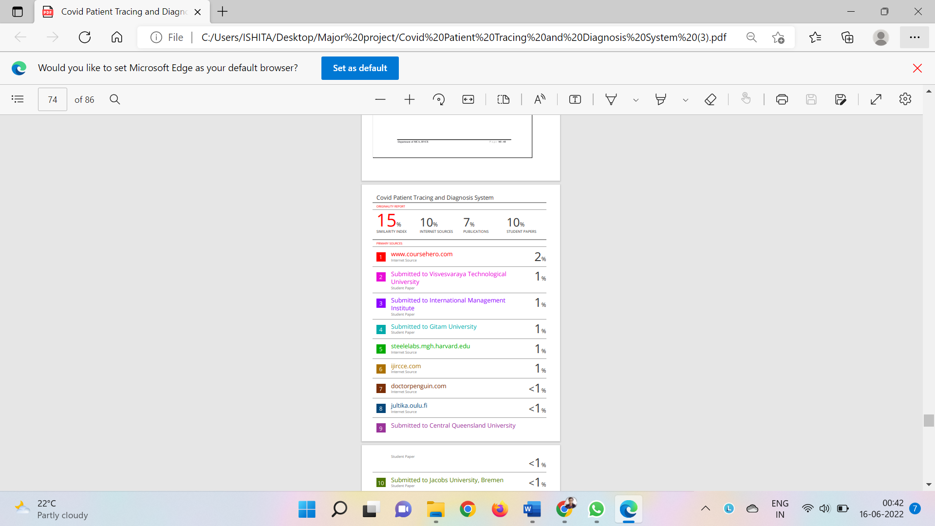



COVID-19 Vaccines Analysis to Predict its impact Across the world

**Ishita Sarkar1,Sridevi Vattikuti2 and Dr. Jasmine K.S3**

1-3*RV College of Engineering/MCA, Bangalore, India*

*Email:ishitasarkar.mca20@rvce.edu.in,srideviv.mca19@rvce.edu.in,* [*jasmineks@rvce.edu.in*](mailto:jasmineks@rvce.edu.in)

## Abstract.

**In recent years ,due to the widespread of COVID-19 pandemic, a large amount of data set is available about the various types of vaccines used by different countries for the protection of their citizens. So it is very important and useful if one can do the effective analysis of the same to make the awareness and the effectiveness of each vaccine. It is found that COVID-19 vaccines increase the immune system, prepare the body to fight against the virus, and reduce the probability of contracting COVID-19.this can be done with the help of regression techniques such as The MAE,MSE,RMSE values to predict and evaluate the observations with more efficiency.The RMSE technique measures the standard deviation of results and provides more accuracy.This analysis helps to find out how COVID-19 vaccines are provided in various countries and the countries where 80% of the population is vaccinated.**

**Keywords. COVID-19, Vaccination, The MAE, MSE, and RMSE value**

1. **INTRODUCTION**

Coronavirus disease (COVID-19) is an infectious disease caused by the SARS-CoV-2 virus. The virus spreads more easily indoors and in crowded places, hence spreading rapidly and causing a pandemic. COVID-19 vaccines provide an effective way to reduce the risk of getting affected by COVID-19. So various countries worked to provide enough vaccines to vaccinate the country's huge population. A wide range of vaccines is developed by different companies to achieve maximum effectiveness. The goal is to analyse how effective vaccines are and how many countries have achieved vaccination for more than 80% of their population and also the popular vaccines. Visualization of data is also done. Various graphs and heat maps can be plotted. Check specifically for a geographical area for how many are vaccinated and from which area has the highest number of vaccinated people. It also checks for the fastest country to vaccinate its people and also shows the impact of different vaccines. So a machine learning technique “An extra-trees regressor", This class implements a meta estimator that fits many randomised decision trees on different sub of the dataset and uses averaging and control over-fitting to improve predictive accuracy. [9]

1. **PROPOSED SYSTEM**
   1. Unique Technical Features

* Using Python Libraries to evaluate and analyze the vaccination data
* Predicting the total and daily vaccination in India
* A thorough analysis of the dataset
  1. Use of Python and Python Libraries

Python is a high-level general-purpose programming language used to create server applications. It is an Object-Oriented programming language that helps us to perform inheritance, overriding, and polymorphism. A Python library, on the other hand, means a collection of modules consisting of lines of code that you can use by importing the modules into any program. Modules such as Pandas, Scikit-Learn, and NumPy are also used for data analysis and Machine Learning. Even Matplotlib is an amazing library that is used for data visualization.

* 1. Machine Learning Algorithm

The Extra Tree Model class implements a meta estimator that fits multiple randomised decision trees (also known as extra-trees) on different dataset properties. Also it uses averaging to boost forecasting accuracy and limit overfitting.

1. **IMPLEMENTATION**

In the proposed analysis the data requires to go through a pre-processing stage where missing data is being removed. After which some analysis is performed on the optimized dataset where it checks for the countries using a particular vaccine, countries to reach 80% vaccination mark, etc. Once the initial analysis is being performed the dataset is cleared further to make it optimized for training a Machine Learning algorithm. Firstly, as the predictions are made for India only we store the rows which have the country like India; Once the data is isolated, feature scaling is performed so that the data can be standardized to a fixed range. The next step is to split the dataset into training and test data. The size of the training data is 0.80 for the entire dataset and the test data consists of the remaining 0.20 for the entire data. After splitting the dataset, the Machine Learning algorithm is applied first to fit the data which builds “a forest of trees from the training set (x, y)”, after which the score can be checked where the coefficient of determination of the prediction is returned and followed by that the predict method is used to predict regression target for X. Once that is done the MAE, MSE, and RMSE is checked.[5][11]

* 1. **ANALYSIS**

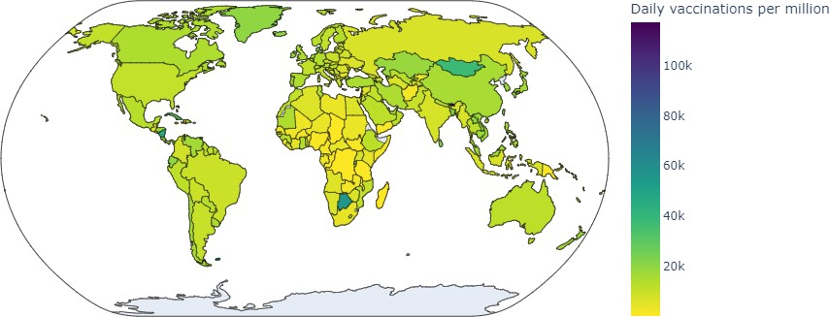

## Figure 1. Daily vaccinations

From Figure 1 which depicts a geographical graph, one can analyze and conclude that the rate of vaccination is different in different countries. Only a few counties were able to achieve over 60k per million vaccination landmarks.

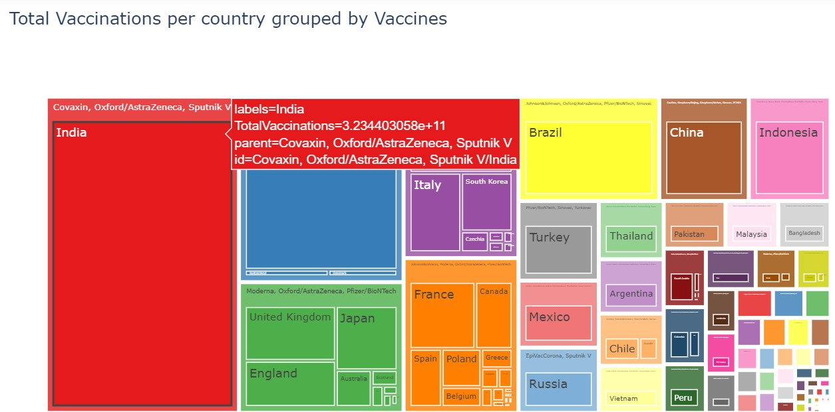

## Figure 2. Total vaccinations per country

Figure 2 shows the total vaccinations to date(as per dataset) for every country and the vaccines which they use, that is the reason why we have grouped the vaccines used by one particular country as we know it's not necessary to have only one type of COVID-19 vaccine in a country so to get the total estimation we clubbed all the vaccines available in one country to calculate the total vaccinations completed.[15]

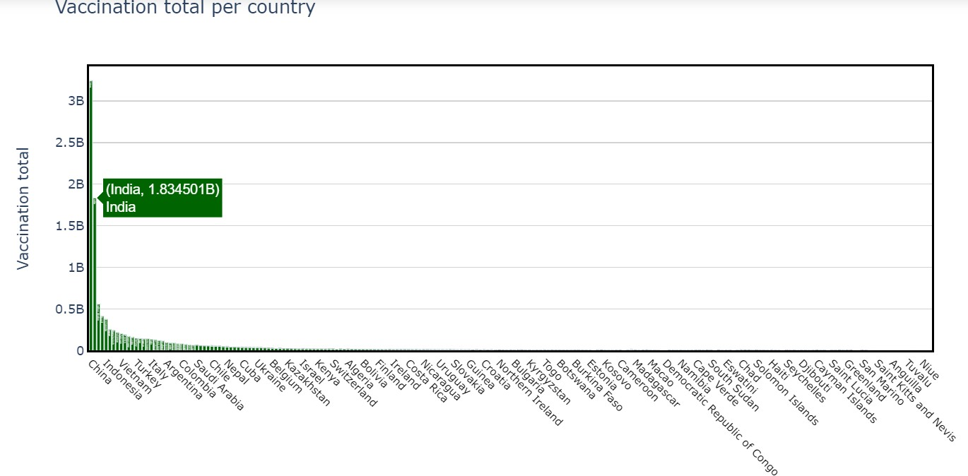

**Figure 3. Total vaccinations per country**

From the above graph, we can spot that China has over 3billon of its population vaccinated and followed by India with over 1.8 billion. This data is different from the above graph as the above graph stated total

vaccination for India as per the grouped vaccine but this graph states just the total estimated vaccination including both the doses.

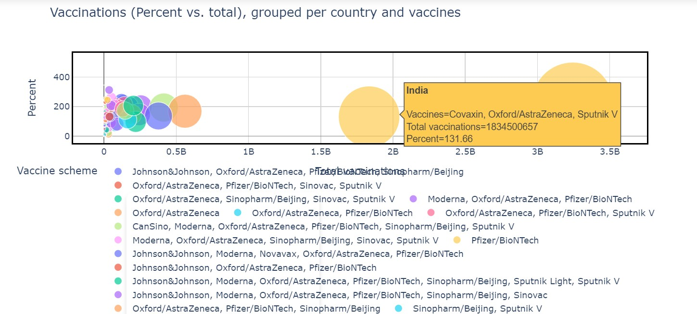

## Figure 4. Vaccination Percent V/s Total

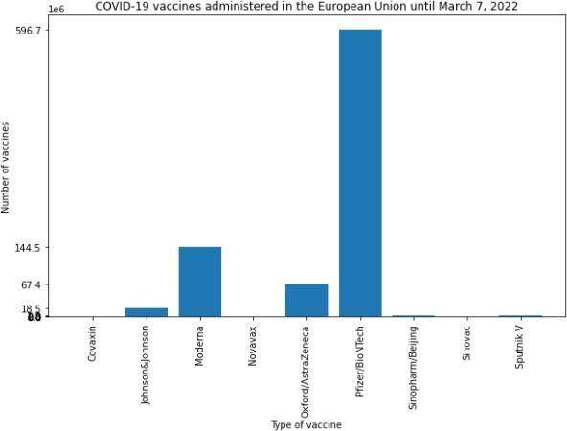It shows the relation between the total vaccination done to what percentage of vaccination is being done based on the countries and vaccines

## Figure 5. Vaccinations administered in European Union

The above graph shows that Pfizer and Moderna are the 2 greatly administered vaccinations in the European Union.

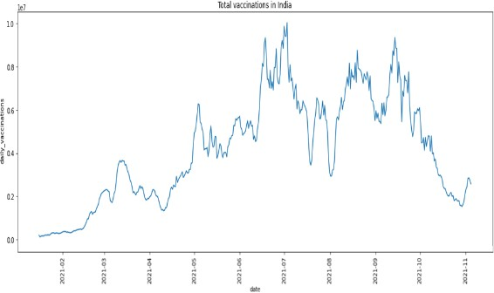

## Figure 6. Vaccinations in India

The graph explains the rate of vaccinations done in India. Initially (2021-02) the rate of vaccination was very low and increased gradually over time and (2021-07) reached the highest in daily vaccines and reduced over time.

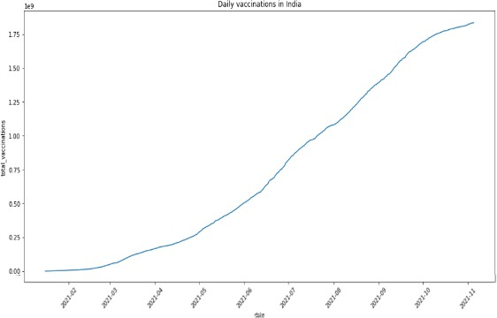

**Figure 7. Daily vaccinations in India**

The graph explains the rate of vaccinations done in India. Initially, the rate of vaccination was very low but reached the highest in daily vaccines over a few months.

## Figure 8. Vaccinated people per hundred

From the above graph, we can see that China has the highest number of vaccinated people per hundred followed by Vietnam, Japan, and other countries.

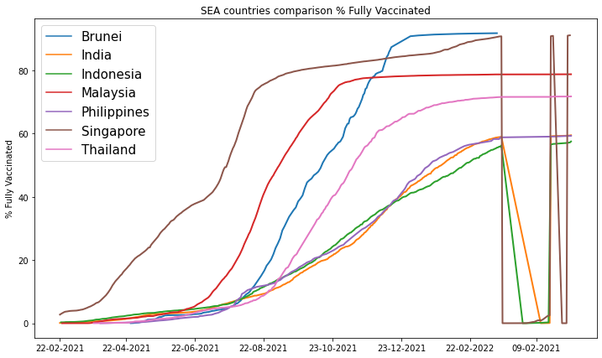

## Figure 9. Vaccination rates of SEA countries

Singapore has the highest vaccination rate among all the SEA countries. Most SEA countries have a vaccination rate close to 60%

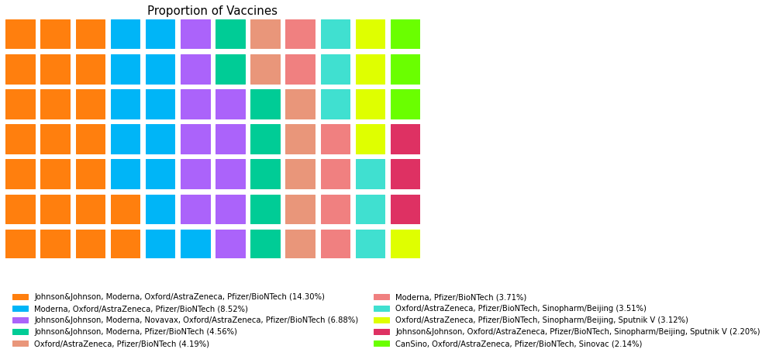

o

## Figure 10. The proportion of the Vaccines

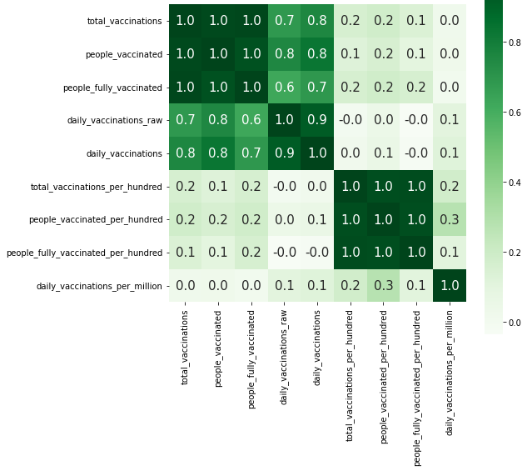

**Figure 11. Correlation between the features**

The above heatmap represents the correlation between the different attributes of the dataset.

|  |  |  |
| --- | --- | --- |
| **Country** | **date** | **people_fully_vaccinated_per_hundred** |
| **South Korea** | 01-01-2022 | 80.20 |
| **Cambodia** | 01-01-2022 | 80.01 |
| **Singapore** | 01-01-2022 | 80.10 |
| **Chile** | 01-01-2022 | 80.16 |
| **Portugal** | 01-01-2022 | 81.10 |
| **Malta** | 01-01-2022 | 80.03 |
| **Cuba** | 01-01-2022 | 80.01 |
| **Gibraltar** | 01-02-2022 | 82.11 |
| **Spain** | 01-02-2022 | 80.05 |
| **Denmark** | 01-02-2022 | 80.12 |
| **Faeroe Islands** | 01-02-2022 | 82.41 |
| **Seychelles** | 01-03-2022 | 80.54 |
| **Argentina** | 01-03-2022 | 80.02 |
| **United Arab Emirates** | 01-03-2022 | 80.18 |
| **Canada** | 02-03-2022 | 80.05 |
| **Qatar** | 03-03-2022 | 87.90 |
| **Cayman Islands** | 03-12-2021 | 80.73 |
| **Ireland** | 05-03-2022 | 80.03 |
| **China** | 06-01-2022 | 80.49 |
| **Brunei** | 07-01-2022 | 80.99 |
| **Pitcairn** | 07-09-2021 | 100.00 |
| **Uruguay** | 09-03-2022 | 80.02 |
| **Guernsey** | 11-01-2022 | 81.01 |
| **Australia** | 11-03-2022 | 80.12 |
| **Niue** | 13-03-2022 | 87.79 |
| **Cook Islands** | 14-03-2022 | 81.04 |

## Table 1. Fastest countries to reach vax = 80% along with dates

* 1. **PREDICTING THE MAE,MSE N RMSE VALUE**

Many regression models rely on distance metrics to determine convergence to the best results. Even the definition of the "best" result needs to be explained quantitatively by the metric. Typical metrics used are mean average error (MAE), root mean square error (MSE), or root mean square error (RMSE). MAE uses the average of all observations to evaluate the absolute distance from the observation (of the data set entry) to the prediction of the regression. Use the absolute value of the distance to properly consider negative errors. This is exactly the situation described in the image above. Another way is to square the distance so that the result is positive. This is done by MSE, and due to the nature of the power function, high errors (or distances) have higher metric weights than low errors. The MSE setback is the fact that the unit of the metric is also squared. Therefore, if the model tries to predict the price in US dollars, MSE will return a number in units (US dollars) ², which is meaningless. It then uses RMSE to reset the MSE error to its original 1 by taking the square root of the MSE error while maintaining the character of penalizing higher errors.[4]

* + 1. Making Predictions

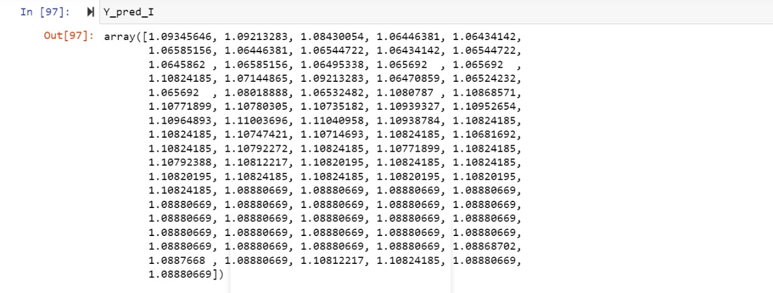Y_pred_I = EXTRAindia.predict(X_test_I) Output:

* + 1. The MAE, MSE, and RMSE Values

print('MAE:',metrics.mean_absolute_error(Y_test_I, Y_pred_I)) print('MSE:',metrics.mean_squared_error(Y_test_I, Y_pred_I)) print('RMSE:',np.sqrt(metrics.mean_squared_error(Y_test_I, Y_pred_I)))

Output:

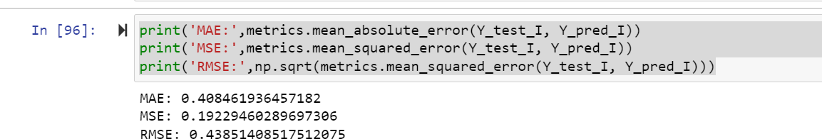

1. **CONCLUSION**

This paper analyses the overall population which is being vaccinated during the pandemic and the types of vaccines which were being used across the globe. Our initial analysis is based on the growth of vaccination in various countries and we could infer from the graphical analysis that in the list of SEA countries most of the countries have crossed the 60% vaccination mark. We have taken India into consideration for most of the analysis. We could observe that India was among the top 10 countries which had a higher rate of vaccinated people per hundred. India was even successful in catering over 1 Billion vaccines and the other observations include the vaccines used in the European Union and found that Pfizer is the commonly used vaccine there. Using the heatmap, we could also observe the correlation between the different attributes of the dataset. Later a regressor model is used to report the lowest value of forecasted errors using the MAE, MSE, and RMSE. The MAE value was 0.408, MSE was 0.192 and RMSE was 0.438. The MAE tells us how an error can be significant that we can expect on average between the actual data and the predicted data. The variance of residuals is evaluated by the MSE, which would be the average of the squared difference between the original and projected values in the data set. The standard deviation of residuals is evaluated by the RMSE.Thus the lower value of MAE, MSE, and RMSE implies that the accuracy of our regression model is high.

1. **REFERENCES**
2. S. Singh and N. Singh, "Big Data analytics," 2012 International Conference on Communication, Information & Computing Technology.
3. S. Mittal and O. P. Sangwan, "Big Data Analytics using Machine Learning Techniques," 2019 9th International Conference on Cloud Computing, Data Science & Engineering (Confluence
4. C. Komalavalli and C. Laroiya, "Challenges in Big Data Analytics Techniques: A Survey," 2019 9th International Conference on Cloud Computing, Data Science & Engineering (Confluence).
5. J. Qi, J. Du, S. M. Siniscalchi, X. Ma, and C. -H. Lee, "On Mean Absolute Error for Deep Neural Network Based Vector-to-Vector Regression," in IEEE Signal Processing Letters.
6. S. Shaikh, J. Gala, A. Jain, S. Advani, S. Jaidhara and M. Roja Edinburgh, "Analysis and Prediction of COVID-19-19 using Regression Models and Time Series Forecasting," 2021 11th International Conference on Cloud Computing, Data Science & Engineering (Confluence).
7. Nijhum Paul, Swapna S. Gokhale;” Analysis and Classification of Vaccine Dialogue in the Coronavirus Era”, IEEE Publications.
8. Sheikh Asif Imran, Md. Tariqul Islam, Celia Shahnaz, Md. Tafhimul Islam, Omar Tawhid Imam, and Moinul Haque, "COVID-19-19 mRNA Vaccine Degradation Prediction using Regularized LSTM Model", *2020 IEEE International Women in Engineering (WIE) Conference on Electrical and Computer Engineering (WIECON-ECE)*.
9. Narayana Darapaneni, Praphul Jain, Rohit Khattar, Manish Chawla, Rijy Vaish and Anwesh Reddy Paduri, "Analysis and Prediction of COVID-19-19 Pandemic in India", *2020 2nd International Conference on Advances in Computing Communication Control and Networking (ICACCCN)*.
10. Liviu-Adrian Cotfas, Camelia Delta, Ioan Roxin, Corina Ioanăş, Dana Simona Gherai, and Federico Tajariol, "The Longest Month: Analyzing COVID-19-19 Vaccination Opinions Dynamics From Tweets in the Month Following the First Vaccine Announcement", IEEE Access, vol. 9, pp. 33203-33223, February 2021.
11. Rutvik Dumre, Kopal Sharma and Karthik Konar, "Statistical and Sentimental Analysis on Vaccination against COVID-19-19 in India", 2021 International Conference on Communication information and Computing Technology (ICCICT).
12. Tamilselvan S; Saravana Kumar R; Priya J; Ramesh R, COVID-19 Vaccination Analysis and Prediction using Machine Learning, IEEE 2021 Smart Technologies, Communication, and Robotics (STCR)
13. Alexis L. Beatty, MD, MAS1,2; Noah D. Peyser, PhD2; Xochitl E. Butcher, BSA2; Analysis of COVID-19-19 Vaccine Type and Adverse Effects Following Vaccination, JAMA Netw Open. 2021;4(12):e2140364. doi:10.1001/jamanetworkopen.2021.40364
14. Voysey M, Clemens SAC, Madhi SA, et al; Oxford COVID-19 Vaccine Trial Group. Safety and efficacy of the ChAdOx1 nCoV-19 vaccine (AZD1222) against SARS-CoV-2: an interim analysis of four randomised controlled trials in Brazil, South Africa, and the UK. Lancet. 2021;397(10269):99-111. doi:10.1016/S0140-6736(20)32661-1
15. Gee J, Marquez P, Su J, et al. First month of COVID-19-19 vaccine safety monitoring—United States, December 14, 2020-January 13, 2021. MMWR Morb Mortal Wkly Rep. 2021;70(8):283-288.
16. Xiucui Han, Pengfei Xu, Qing Ye, Analysis of COVID-19-19 vaccines: Types, thoughts, and application; First published: 15 August 2021 https://doi.org/10.1002/jcla.23937Citations: 2
17. **BIOGRAPHIES**

# Ishita Sarkar is a student in the Department of Master of Computer Application, RV College of Engineering and she is also working as a Reporting Analyst Intern in EXL Services. She completed her Bachelor of Computer Application from Ramaiah Institute of Business Studies, Mathikere.

Sridevi Vattikuti, currently working as a Reporting Analyst intern in EXL services and also pursuing Master's in Computer Application at RV College of Engineering, Banglore. She completed her Bachelor's in Computer Applications from women's college, Ballari.

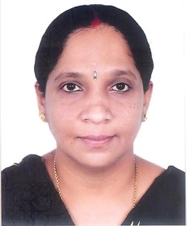Dr. Jasmine K.S is an Associate Professor in the Department of MCA, RV College of Engineering®, Bengaluru